The Pleasure of Travelling
Sandra and Paul were going to Florence. They (pack) their and (prepare) the . They (remember) to take the , the 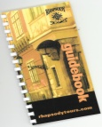 and even the  . Next day early in the morning they (go) to the 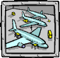 to take the 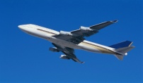 to Bologna. Unfortunately, the flight
(be) delayed so they (have) to wait 2 hours before they (take) off. After they had arrived to Bologna they (have) to wait in a long 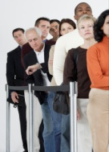 to the passport control and then for their . Then they (head) towards the railway station to catch the 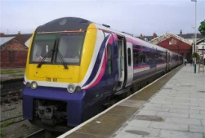 to Florence. When they (reach) the

platform, they (realise) they had missed the train and (have) to wait an hour

for the next one.

On the train, Sandra and Paul were planning what to visit first in Florence.
They (agree) they both (want) to see the famous 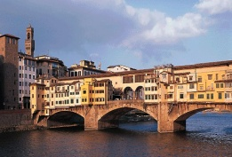 and the 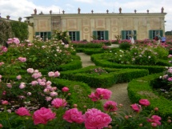 . After they had got off the train in Bologna, they (look) for
a 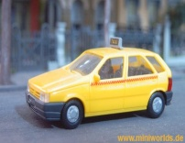 that would take them to the . There (be) no

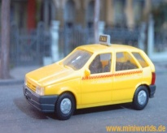 available so they (decide) to walk instead. On the way to the

they (get) lost and (have) to ask for directions several times.

Finally, they (get) to the . After a quick snack they (go) straight to . Next morning they (get up) and (open) the . Outside it was  heavily…

