Hello students! How are you?
Today the theme of our lesson is : "Unit revision ”

- Do you like poems?
- What poems do you know?

Now, open your books on page 24.
Let's revise unit 2
Let's do Еx 1-6

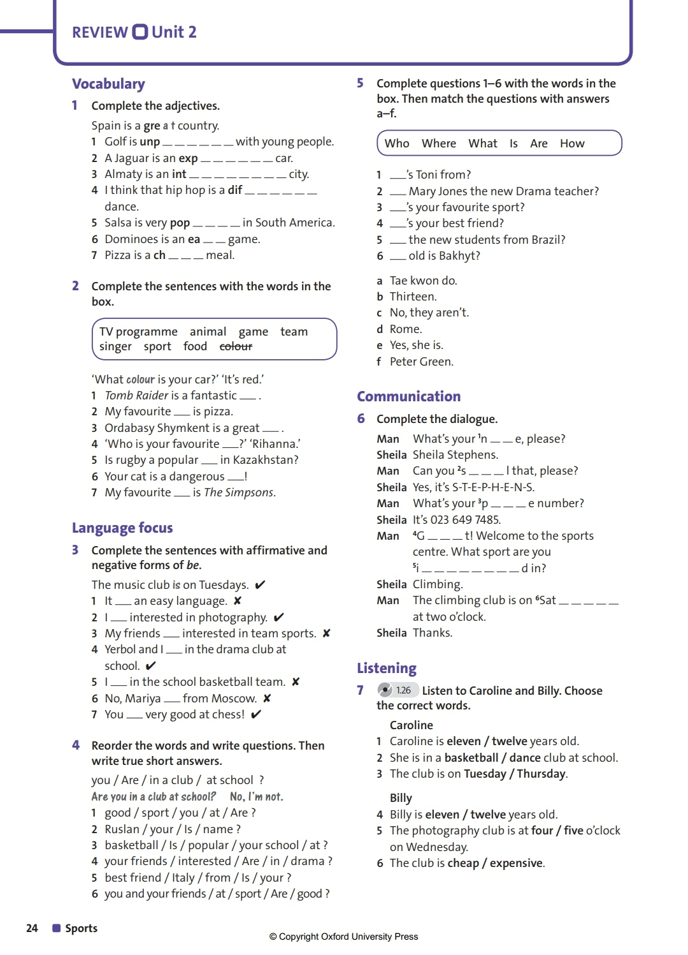

OK! Excellent job!!!

