The plan of student independent work

Subject: English

Grade: 5

Term: 3

Unit 6 Fantasy World

Lesson plan: 12

Theme of the lesson: Comparative and superlative adjectives

Aim: by the end of the lesson you will be able to use comparative and superlative in speech

Procedure:

1. Read the chart:

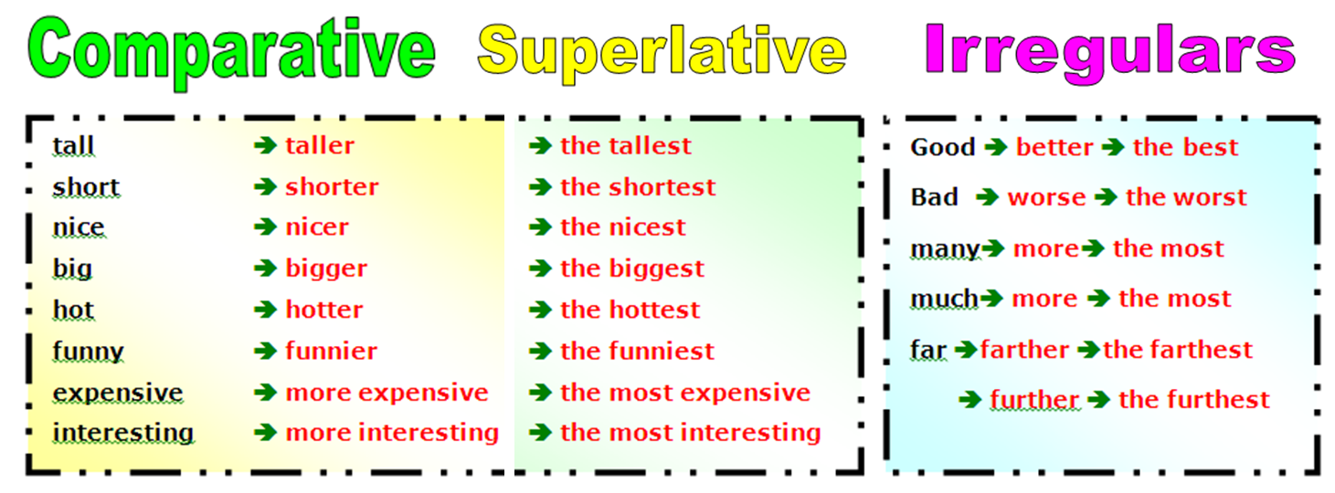

1. Fulfill the exercise:

