https://znanija.com/task24700022

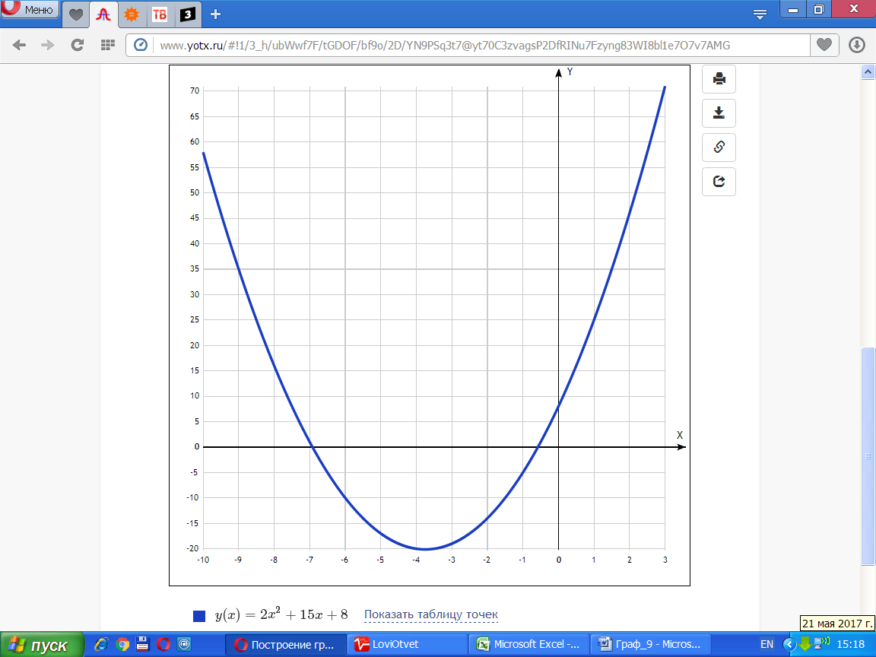

[**Таблица точек**](javascript:void(0);)

|  |  |
| --- | --- |
| **x** | **y** |
| -10 | 58 |
| -9 | 35 |
| -8 | 16 |
| -7 | 1 |
| -6 | -10 |
| -5 | -17 |
| -4 | -20 |
| -3 | -19 |
| -2 | -14 |
| -1 | -5 |
| 0 | 8 |
| 1 | 25 |
| 2 | 46 |
| 3 | 71 |