Функция $y=\log_{5}{x}$
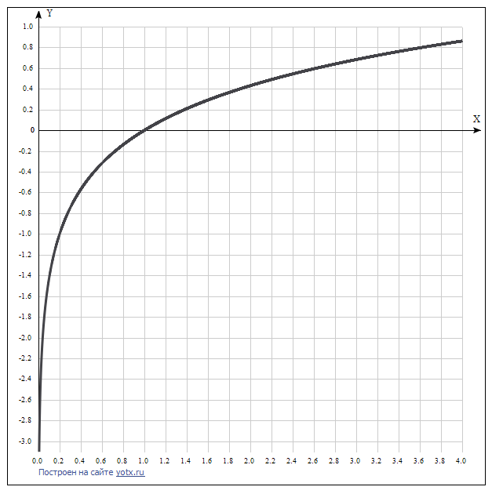

x | y
0.0 | -
0.2 | -1
0.4 | -0.57
0.6 | -0.32
0.8 | -0.14
1.0 | 0
1.2 | 0.11
1.4 | 0.21
1.6 | 0.29
1.8 | 0.37
2.0 | 0.43
2.2 | 0.49
2.4 | 0.54
2.6 | 0.59
2.8 | 0.64
3.0 | 0.68
3.2 | 0.72
3.4 | 0.76
3.6 | 0.8
3.8 | 0.83
4.0 | 0.86

