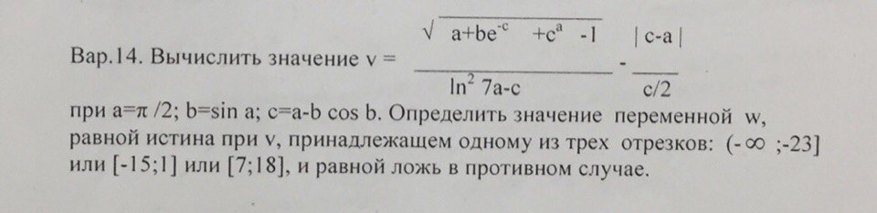
#include<stdio.h>
#include<math.h>
using namespace std;
int main()
{
double a,b,c,v,e;
bool w;
a=M_PI/2;
b=sin(a);
c=a-b*(cos(b));
v=(sqrt((a+(b/pow(e,c))+pow(c,a)-1))/log(7*a-c)*log(7*a-c))-2*fabs(c-a)/c;
w=(v<=-23)||((v>=-25)&&(v<=1))||((v>=7)&&(v<=18));
printf("%d",w);
return 0;
}

