6th form. Test №10

1. Выберите подходящее по смыслу слово.
1 What’s the weather like/temperature today?
2 It’s boiling/freezing hot in here.
3 It’s going to be a wet/sunny day, so take your umbrella.
4 Wear your raincoat/dress. It’s raining.
5 She put on her trousers/gloves to keep her hands warm.
6 It’s snowy! Let’s go shopping/skiing.
7 Do you want to visit the art/party gallery?
8 Ann decided to travel/visit around the world.
9 They want to go/see shopping..
10 Betty makes/rents a lot of pictures when she’s on holiday.

2. Поставьте глаголы в скобках в будущее время (will/won’t).
1. Dan …. (meet) us at the airport.
2. Sally …. (miss) her plane if she doesn’t hurry.
3. Peter …. (go) whitewater rafting tomorrow.
4. We … (go) shopping now. It’s too late.
5. She ….. (go) to school today. She is ill.
6. Don’t stay in the sun or you …. (get) sunburn.

3. Прочитайте текст и ответьте на вопросы

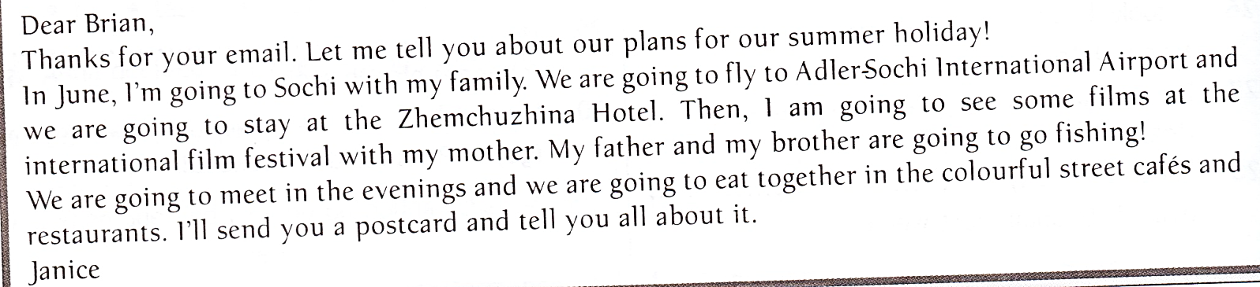
1. When is Janice going to go to Sochi?
2. How is Janice’s family going to travel to Sochi?
3. Where are they going to stay?
4. What is Janice going to see?
5. What is Janice going to send to Brian?

