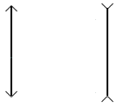
F
F
F

F
2F
2F

