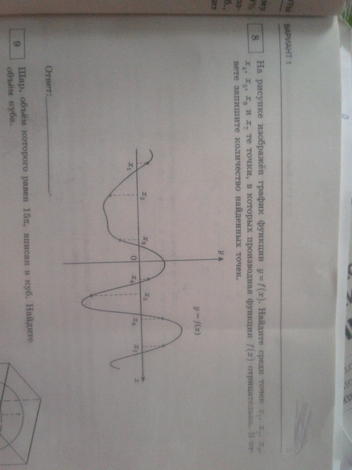
f’(x)<0
f’(x)<0
f’(x)<0

