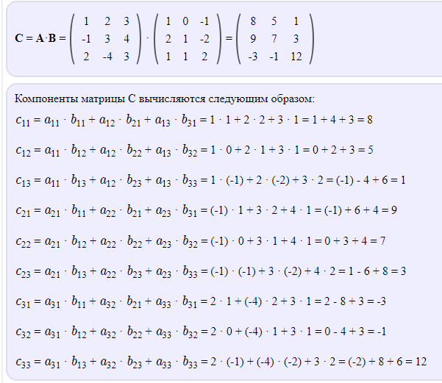
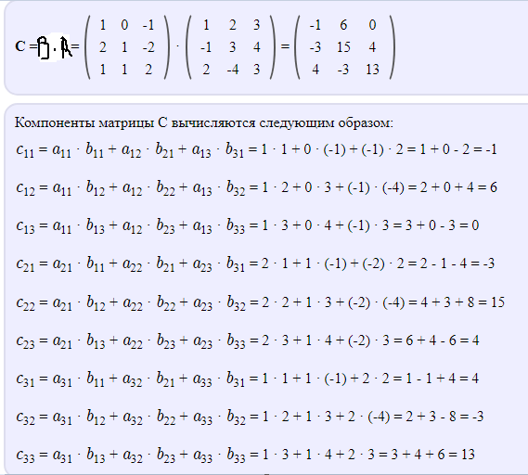

$$a) f^{'}\left(x\right)=-sinxe^{cosx}+c$$
$$б) f^{'}\left(x\right)=\frac{{\left(ln\sqrt{x}\right)}^{'}*\sqrt{x+1}-{\left(ln\sqrt{x}\right)}^{ }*\left(\sqrt{x+1}\right)'}{{\sqrt{x+1}}^{2}}=\frac{\frac{1}{\sqrt{x}*2√x}\sqrt{x+1}-ln\sqrt{x}*\frac{1}{2\sqrt{x+1}}}{x+1}+c=$$
$$=\frac{\frac{\sqrt{x+1}}{2x}-\frac{ln\sqrt{x}}{2\sqrt{x+1}}}{x+1}+c=\frac{\frac{\left(\sqrt{x+1}*\sqrt{x+1}\right)-xln\sqrt{x}}{2x*\sqrt{x+1}}}{x+1}+c=\frac{x+1-xln\sqrt{x}}{2x\left(x+1\right)*\sqrt{x+1}}$$

