Sample questions and mark scheme
Tasks for the Summative Assessment for the term 1

READING

Task. Read the text about four learners’ daily routine.

What do they do after school?

My name is Max. After school, I help my mum and dad. Then I go to the park. There I meet my friends and we play different games. When I come home I usually play chess.

I am Julia. After school, I like drawing and painting pictures. Then I write stories. I put the stories and pictures on my bedroom wall.

I am Luke. After school, I do my homework. Then I listen to my CDs and when I have some spare time I sing songs. In the evenings I prefer reading.

My name is Sara. I go swimming every Monday. I play tennis with my friends every Tuesday. Every Thursday I skate in the park with my sister.

Read the text again and identify who does each activity. Write the Learners’ names or first letters next to the phrases. The first task is done for you as an example.

M = Max, J = Julia, L = Luke, S = Sara.

Example: go to the park M___
- enjoy Art ___ [1]
- do sport activities ___ [1]
- like music ___ [1]

- keen on reading _____ [1]
- spend time with friends ____ [1]
- do house work____ [1]

Total [6]

WRITING

Task. Your pen- friend has sent you a postcard of his/her hometown.

Write a postcard to your friend about your hometown. The sample postcard will help you to write a reply.

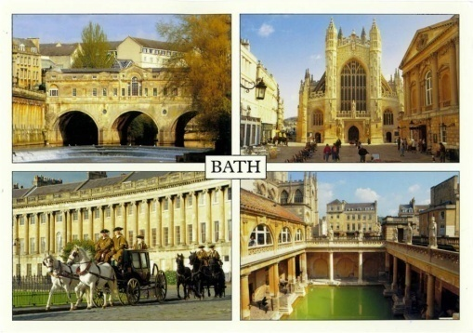

Hello dear friend,

This is a postcard of my town. My town is not very big, but I think it is a fantastic place. My favourite place is the Castle Bath – I usually go there with my friends. Can you send me a postcard of your town? How big is your town? What is your favorite place in the town? Where do you usually go at the weekends?

Love,

Alex

Write your answer to Alex. Make a plan of your writing and answer the questions.

___________________________________________________________________________________________________________________________________________________________________________________________________________________________________________________________________________________________________________________________________________________________________________________________________________________________________________________________________________________________________________________________________________________________________________________________________________________________________________________________________________________________________________________________________________________________________________________________________________________________________________________________________________________________________________________________________________________________________________________________________________________________________________________________________________________________________________________________________________________________________________________________________________________________________________________________________________________________________________________________

Total [6]

Task. Choose one of the pictures below and describe it. Answer the questions:

- What can you see in the picture?
- Where are people or cartoon characters?
- What are they doing?

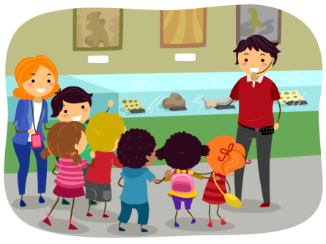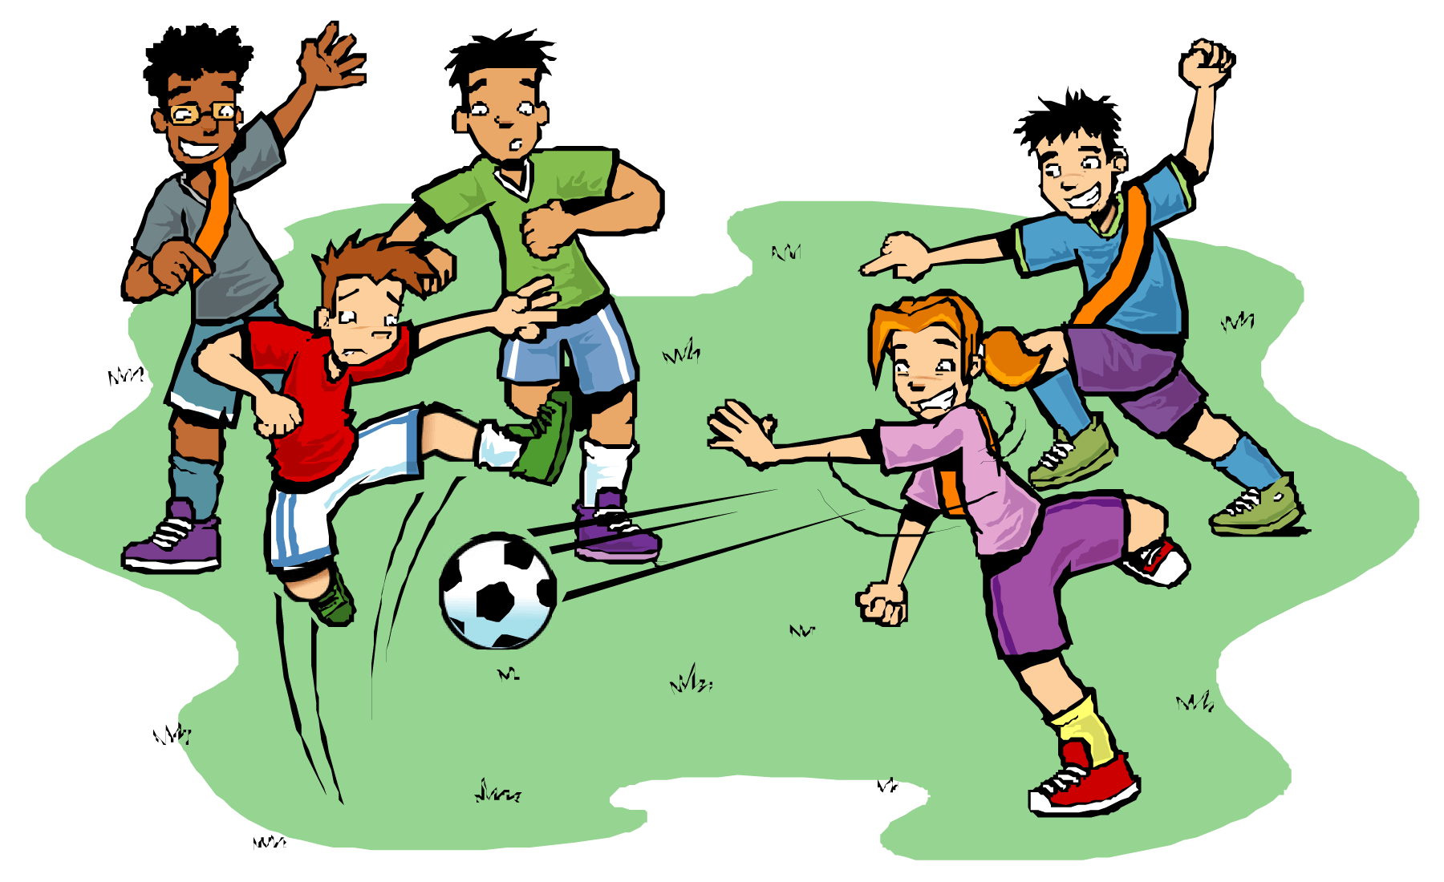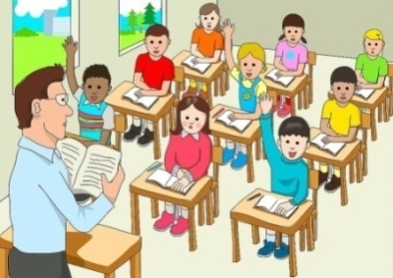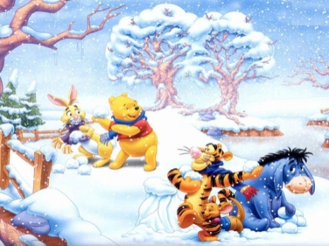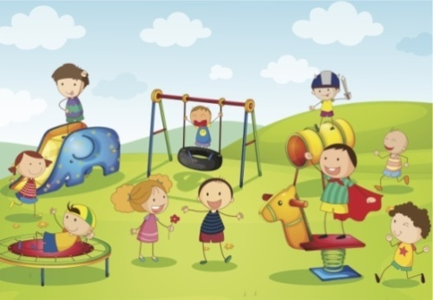

Total [3]

