**Sample questions and mark scheme  
Tasks for Summative Assessment for term 3  
Listening  
Task 1. You will hear a conversation between a girl and a boy, who wants to be in a band. You  
will hear the conversation twice.  
Choose the best answer, A, B, C or D and put a tick (**˅**) in front of the correct option  
1.** What is the location of the conversation?  
A. at the concert. ______  
B. in the University. ______  
C. in the band audition. ______  
D. in the garage. ______  
[1]  
**2.** Why did the boy want to be in a band?  
A. He enjoyed music, especially singing ______  
B. He could not play any music instrument ______  
C. He wanted to play the piano ______  
D. He wanted to join his favourite music band______  
[1]  
**3.** Who did the girl need in a band?  
A. a good singer ______  
B. a guitarist ______  
C. a singer, a guitarist and a drummer _____  
D. a drummer ______  
[1]  
**4.** What instrument did the boy try to play?  
A. the violin ______  
B. the trombone ______  
C. the harp ______  
D. the drums ______  
[1]  
**5.** What did the girl say to him?  
A. I’ll call you next week ______  
B. I’ll call you tomorrow. ______  
C. I won’t call you next week. ______  
D. Sorry, you aren’t suitable for us. ______ [1]  
**[5]  
Reading  
Task 2. Read the story about some mythical creatures and answer True/False questions.  
Write *True* or *False* in front of each statement.**There are lots of stories about fantasy animals. Sometimes the animals were strong and killed people; sometimes they were signs of good luck. Here is some information about six famous fantasy animals.  
**Unicorns** were beautiful creatures like horses. They had a long pointed horn in the middle of their foreheads. The horn was magical. If a unicorn put its horn in dirty water,the water became clean. Unicorns were a sign of good luck, but only honest people could see them.  
**Centaurs** were wild creatures. They were half-man, half-horse. They lived a long time ago in  
Greece. Most centaurs were soldiers but one centaur was different. His name was Chiron. He wasa famous teacher. When he died he changed into a star called Sagittarius.  
**The Minotaur** was a very scary creature for people. It had a bull’s head and a man’s body. It lived in a labyrinth on an island called Crete. If anybody went into the labyrinth, they got lost and could never get out again. Every year, people from the island of Minos sent 7 boys and girls into the labyrinth. The Minotaur ate them.One year, a brave man called Theseus killed the Minotaur. He took a ball of string from a princess and used it to go in and out  
of the labyrinth.  
**Chinese dragons** were good, friendly and intelligent. They were made from the parts of nine animals:a snake’s body, a fish’s scales, a clam’s stomach, a tiger’s feet, an eagle’s claws, a camel’s face, a deer’s antlers, a cow’s ears and golden eyes.  
  
1. Sometimes the animals seemed to be really powerful and dangerous for people, but  
sometimes they were accepted as a luck…………………………………………………………[1]  
2. People were afraid of the Minotaur………………………………………………………[1]  
3. Unicorns were a sign of bad luck…………………………………………………………[1]  
4. The Minos island people sent 7 boys and girls into the labyrinth each year. …………….[1]  
5. Chinese dragons had a tiger’s face…………………………………………………..……[1]  
**[5]  
Writing  
Task 3 Look at the picture and write a short story in 60-70 words.  
Make sure that you answered the following questions:**

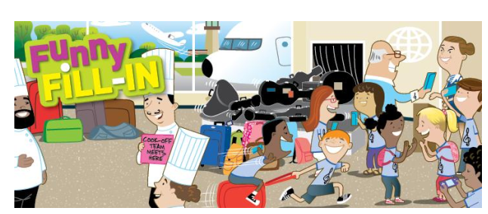

|  |
| --- |
| • Where was that story taking place? • Who is the main character? • What problem did he/she face? • What happened in the end? |

……………………………………………………………………………………… ….  
………………………………………………………………………………………….  
………………………………………………………………………………………….  
………………………………………………………………………………………… .  
…………………………………………………………………………………… … ….  
………………………………………………………………………………………

**Speaking  
Task 4.** • what mythical creature he or she likes;  
• where the mythical creature lived;  
• to describe the mythical creature;  
• what it (the mythical creature) could and couldn’t do;  
• why he/she likes that mythical creature.

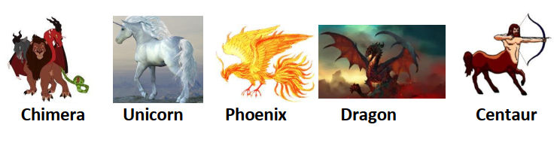• the name of mythical creature and what film, cartoon or book it is from;  
• where the mythical creature lived;  
• how it looked like*;*• what it could / couldn’t do*;*• why you like it.