- Заполни пропуски при помощи правильной формы глагола в скобках
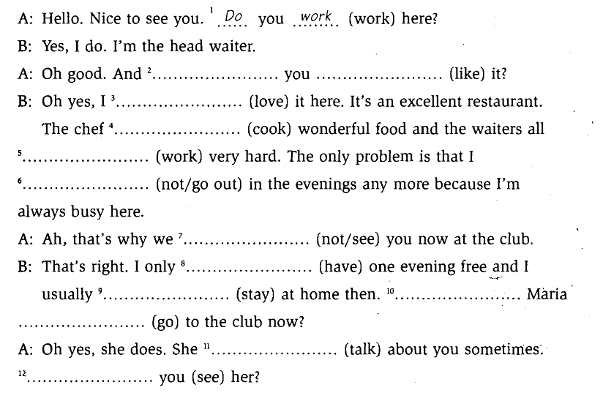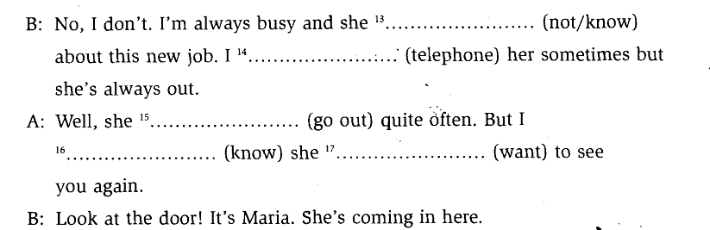
- Поставь предложения в отрицательную форму
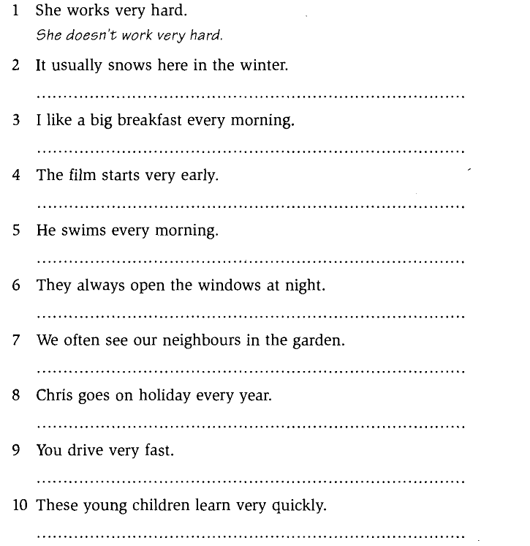

A: Oh good And do you like it?
B: I love
The chief cooks
work very hard
don`t go out

A:don`t see
B: I only have
I usually stay
Does Maria go

A: She talks
Do you see her?
B: she doesn`t know about this…
I telephone her sometimes
A:
She goes out
I know
she wants

2.
2. It usually doesn`t snow here…
3 I don`t like a big….
4 The film doesn`t start …
5 He doesn`t swim…
6. They always don`t open …
7 We often don`t see …
8 Chris doesn`t go on …
9 You don`t drive….
10 These young children don`t learn

