$$y=x^{4}-4x^{3}+20$$
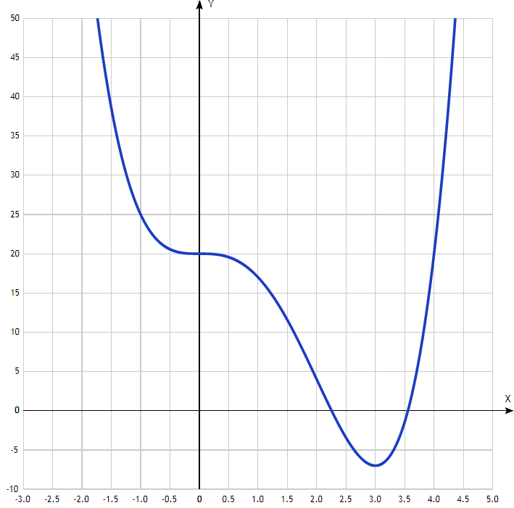

x | y
-3.0 | 209
-2.5 | 121.6
-2.0 | 68
-1.5 | 38.6
-1.0 | 25
-0.5 | 20.6
0 | 20
0.5 | 19.6
1.0 | 17
1.5 | 11.6
2.0 | 4
2.5 | -3.4
3.0 | -7
3.5 | -1.4
4.0 | 20
4.5 | 65.6
5.0

