https://znanija.com/task/23798487
№ 4,а) {(x-3y)(x+y) = 0;
{2x²-y² = 17.
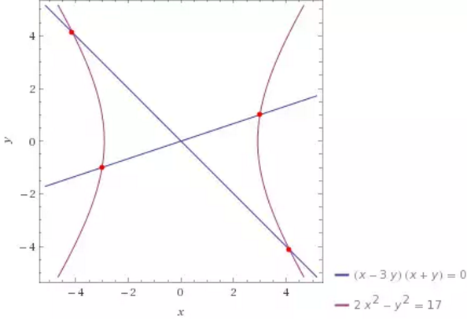
№4,б) {x+y+xy = 7;
{x²+y² = 10.
