Nazarbaev Intellectual school
Supply and Demand
Project work
by Kenzhegaliev Miras

Kokshetau 2013

Contents
What is Supply and Demand? 2
The Law of Demand 3
The Law of Supply 4
Time and Supply 4
Supply and Demand Relationship 5
Equilibrium 6
Disequilibrium 7
Shifts vs. Movement 9
Used resources 11

What is Supply and Demand?

Supply and demand is perhaps one of the most fundamental concepts of economics and it is the backbone of a market economy. Demand refers to how much (quantity) of a product or service is desired by buyers. The quantity demanded is the amount of a product people are willing to buy at a certain price; the relationship between price and quantity demanded is known as the demand relationship. Supply represents how much the market can offer. The quantity supplied refers to the amount of a certain good producers are willing to supply when receiving a certain price. The correlation between price and how much of a good or service is supplied to the market is known as the supply relationship. Price, therefore, is a reflection of supply and demand.
The relationship between demand and supply underlie the forces behind the allocation of resources. In market economy theories, demand and supply theory will allocate resources in the most efficient way possible. How? Let us take a closer look at the law of demand and the law of supply.

The Law of Demand

The law of demand states that, if all other factors remain equal, the higher the price of a good, the less people will demand that good. In other words, the higher the price, the lower the quantity demanded. The amount of a good that buyers purchase at a higher price is less because as the price of a good goes up, so does the opportunity cost of buying that good. As a result, people will naturally avoid buying a product that will force them to forgo the consumption of something else they value more. The chart below shows that the curve is a downward slope.
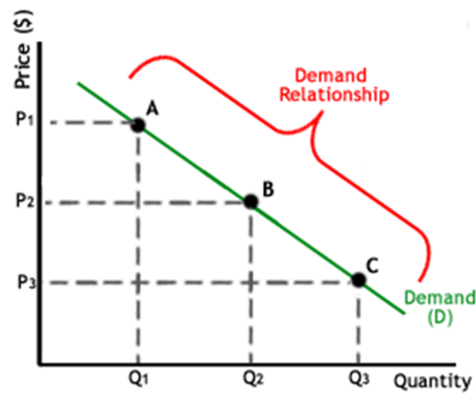

A, B and C are points on the demand curve. Each point on the curve reflects a direct correlation between quantities demanded (Q) and price (P). So, at point A, the quantity demanded will be Q1 and the price will be P1, and so on. The demand relationship curve illustrates the negative relationship between price and quantity demanded. The higher the price of a good the lower the quantity demanded (A), and the lower the price, the more the good will be in demand (C).

The Law of Supply

Like the law of demand, the law of supply demonstrates the quantities that will be sold at a certain price. But unlike the law of demand, the supply relationship shows an upward slope. This means that the higher the price, the higher the quantity supplied. Producers supply more at a higher price because selling a higher quantity at higher price increases revenue.
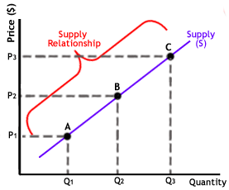
A, B and C are points on the supply curve. Each point on the curve reflects a direct correlation between quantities supplied (Q) and price (P). At point B, the quantity supplied will be Q2 and the price will be P2, and so on.

Time and Supply

Unlike the demand relationship, however, the supply relationship is a factor of time. Time is important to supply because suppliers must, but cannot always, react quickly to a change in demand or price. So it is important to try and determine whether a price change that is caused by demand will be temporary or permanent.

Let's say there's a sudden increase in the demand and price for umbrellas in an unexpected rainy season; suppliers may simply accommodate demand by using their production equipment more intensively. If, however, there is a climate change, and the population will need umbrellas year-round, the change in demand and price will be expected to be long term; suppliers will have to change their equipment and production facilities in order to meet the long-term levels of demand.

Supply and Demand Relationship

Now that we know the laws of supply and demand, let's turn to an example to show how supply and demand affect price.
Imagine that new laptops are released for $2000. Because the company's previous analysis showed that consumers will not demand laptops at a price higher than $2000, only ten CDs were released because the opportunity cost is too high for suppliers to produce more. If, however, the ten laptops are demanded by 20 people, the price will subsequently rise because, according to the demand relationship, as demand increases, so does the price. Consequently, the rise in price should prompt more laptops to be supplied as the supply relationship shows that the higher the price, the higher the quantity supplied.
If, however, there are 30 laptops produced and demand is still at 20, the price will not be pushed up because the supply more than accommodates demand. In fact after the 20 consumers have been satisfied with their laptop purchases, the price of the leftover laptops may drop as laptop producers attempt to sell the remaining ten laptops. The lower price will then make the laptops more available to people who had previously decided that the opportunity cost of buying the laptop at $2000 was too high.

Equilibrium

When supply and demand are equal (i.e. when the supply function and demand function intersect) the economy is said to be at equilibrium. At this point, the allocation of goods is at its most efficient because the amount of goods being supplied is exactly the same as the amount of goods being demanded. Thus, everyone (individuals, firms, or countries) is satisfied with the current economic condition. At the given price, suppliers are selling all the goods that they have produced and consumers are getting all the goods that they are demanding.
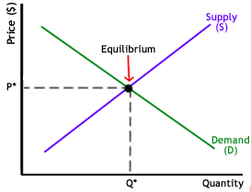
As you can see on the chart, equilibrium occurs at the intersection of the demand and supply curve, which indicates no allocate inefficiency. At this point, the price of the goods will be P* and the quantity will be Q*. These figures are referred to as equilibrium price and quantity.
In the real market place equilibrium can only ever be reached in theory, so the prices of goods and services are constantly changing in relation to fluctuations in demand and supply.

Disequilibrium

Disequilibrium occurs whenever the price or quantity is not equal to P* or Q*.
- Excess Supply
if the price is set too high, excess supply will be created within the economy and there will allocate inefficiency.
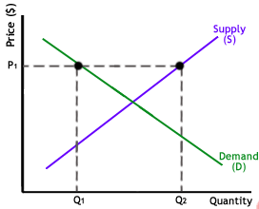
At price P1 the quantity of goods that the producers wish to supply is indicated by Q2. At P1, however, the quantity that the consumers want to consume is at Q1, a quantity much less than Q2. Because Q2 is greater than Q1, too much is being produced and too little is being consumed. The suppliers are trying to produce more goods, which they hope to sell to increase profits, but those consuming the goods will find the product less attractive and purchase less because the price is too high.
2. Excess Demand
Excess demand is created when price is set below the equilibrium price. Because the price is so low, too many consumers want the good while producers are not making enough of it.
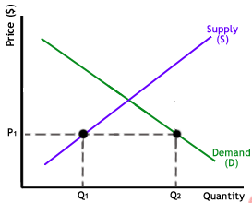
In this situation, at price P1, the quantity of goods demanded by consumers at this price is Q2. Conversely, the quantity of goods that producers are willing to produce at this price is Q1. Thus, there are too few goods being produced to satisfy the wants (demand) of the consumers. However, as consumers have to compete with one other to buy the good at this price, the demand will push the price up, making suppliers want to supply more and bringing the price closer to its equilibrium.

Shifts vs. Movement

For economics, the "movements" and "shifts" in relation to the supply and demand curves represent very different market phenomena:
1. Movements
A movement refers to a change along a curve. On the demand curve, a movement denotes a change in both price and quantity demanded from one point to another on the curve. The movement implies that the demand relationship remains consistent. Therefore, a movement along the demand curve will occur when the price of the good changes and the quantity demanded changes in accordance to the original demand relationship. In other words, a movement occurs when a change in the quantity demanded is caused only by a change in price, and vice versa.
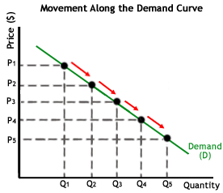
Like a movement along the demand curve, a movement along the supply curve means that the supply relationship remains consistent. Therefore, a movement along the supply curve will occur when the price of the good changes and the quantity supplied changes in accordance to the original supply relationship. In other words, a movement occurs when a change in quantity supplied is caused only by a change in price, and vice versa.
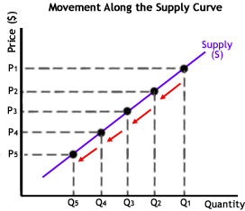
2. Shifts
A shift in a demand or supply curve occurs when a good's quantity demanded or supplied changes even though price remains the same. For instance, if the price for a bottle of juice was $2 and the quantity of juice demanded increased from Q1 to Q2, then there would be a shift in the demand for juice. Shifts in the demand curve imply that the original demand relationship has changed, meaning that quantity demand is affected by a factor other than price. A shift in the demand relationship would occur if, for instance, juice suddenly became the only type of such drinks available for consumption.
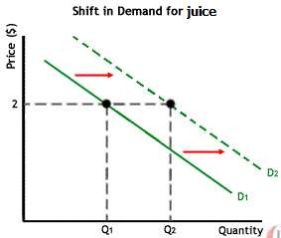
Conversely, if the price for a bottle of juice was $2 and the quantity supplied decreased from Q1 to Q2, then there would be a shift in the supply of juice. Like a shift in the demand curve, a shift in the supply curve implies that the original supply curve has changed, meaning that the quantity supplied is affected by a factor other than price. A shift in the supply curve would occur if, for instance, a natural disaster caused a mass shortage of hops; juice manufacturers would be forced to supply less juice for the same price.
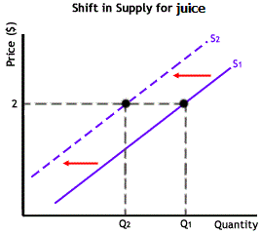

Used resources

- “Supply and demand” From Wikipedia, the free encyclopedia. Link: http://en.wikipedia.org/wiki/Supply_and_demand
- “Economics Basics: Supply and Demand” by Reem Heakal. Link: http://www.investopedia.com/university/economics/economics3.asp

