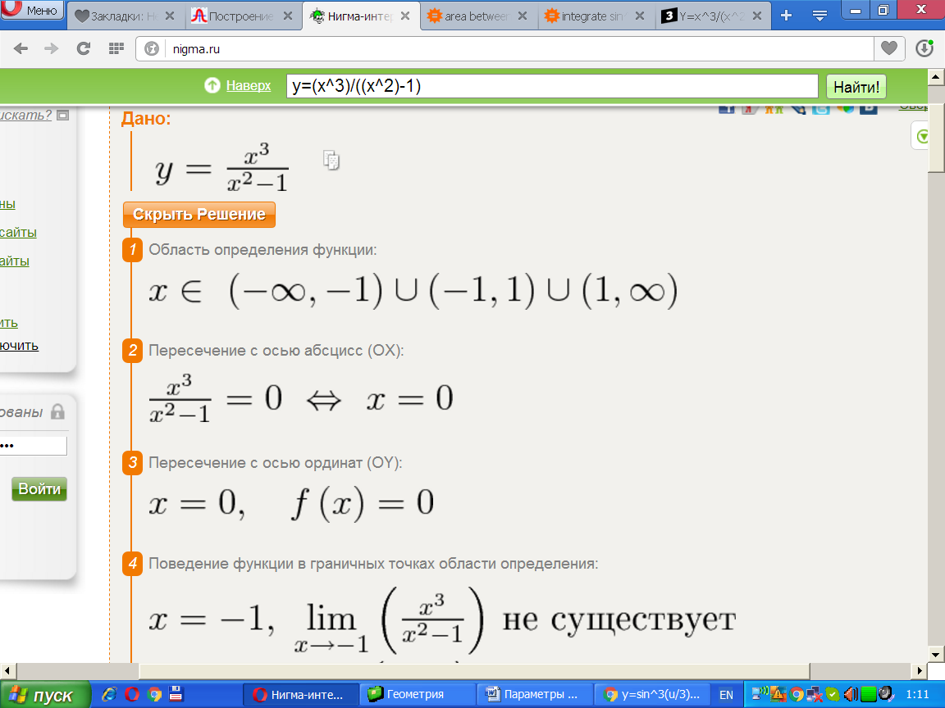

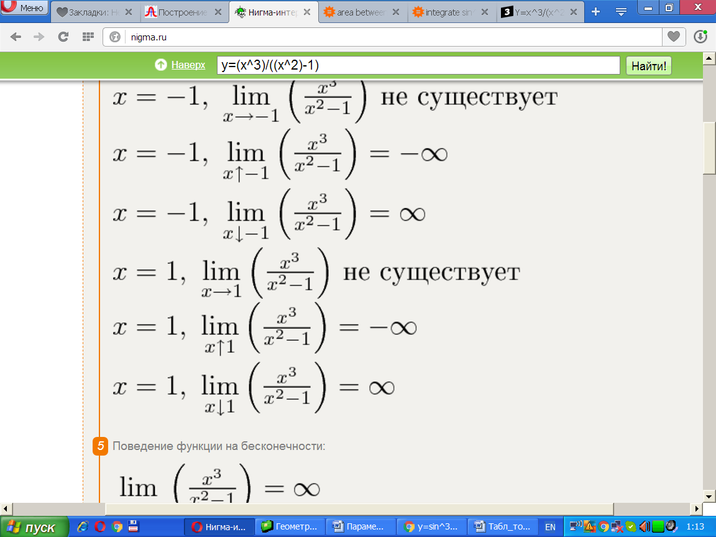

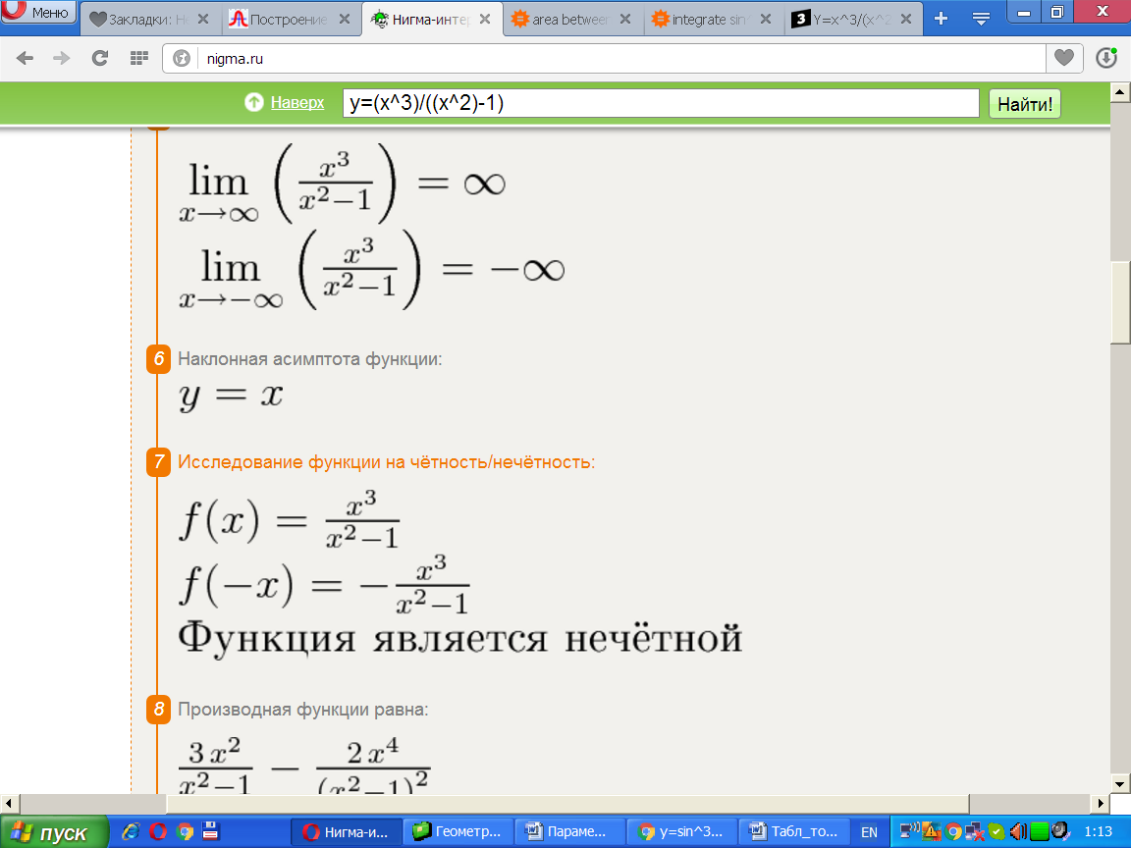

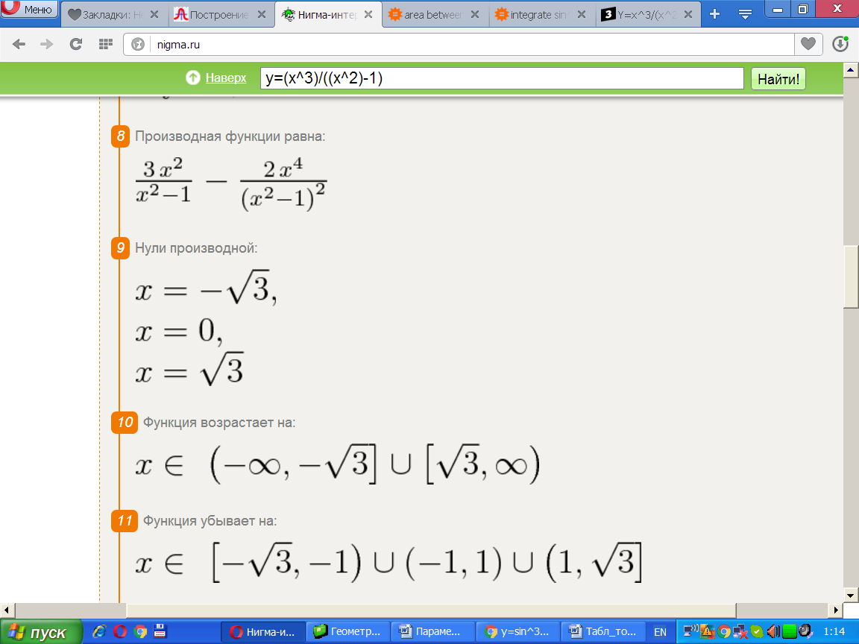

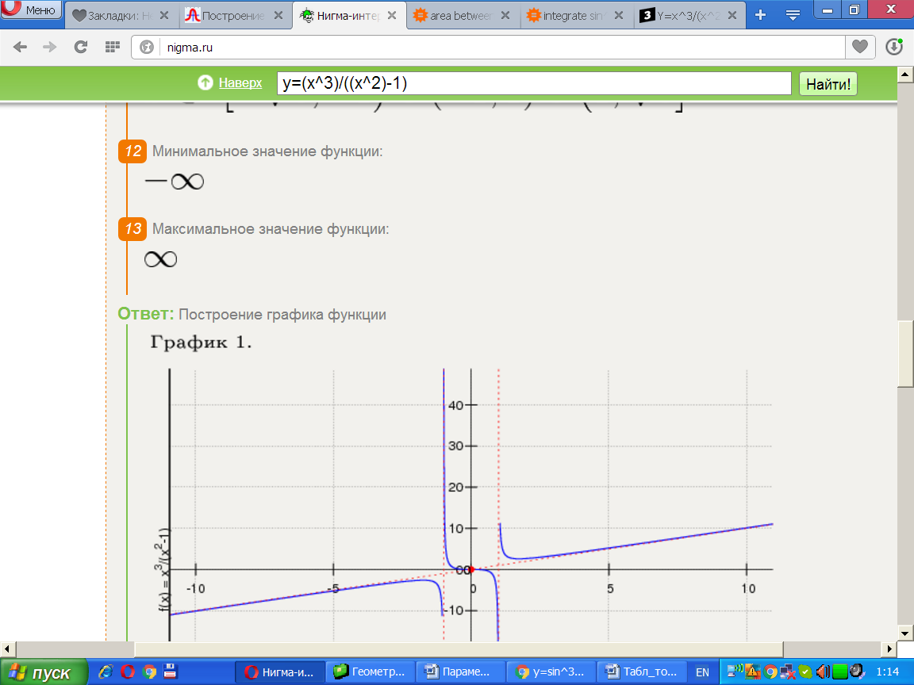

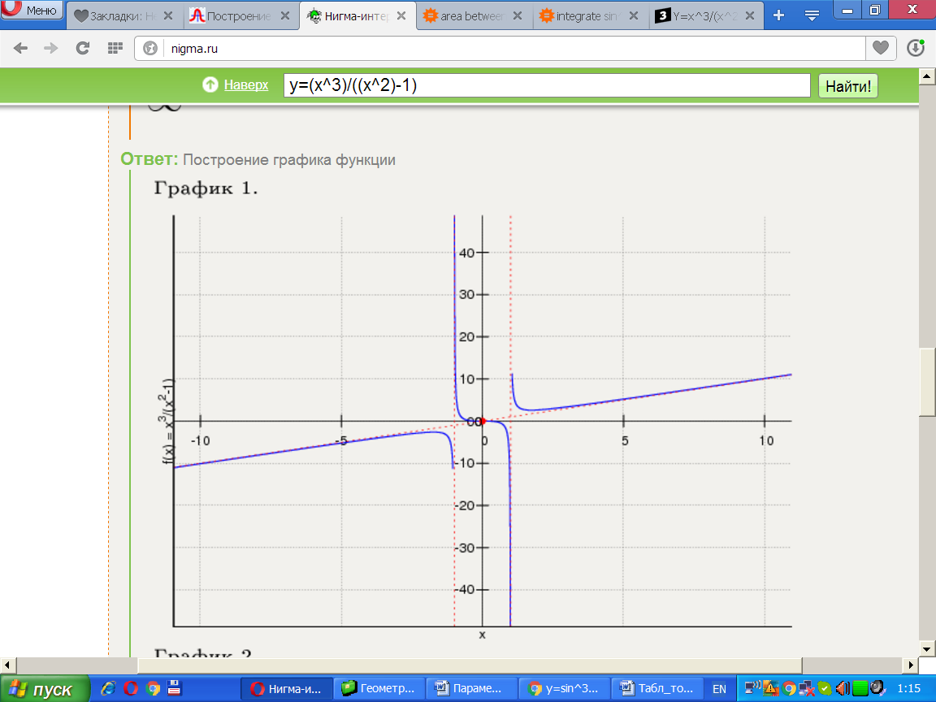

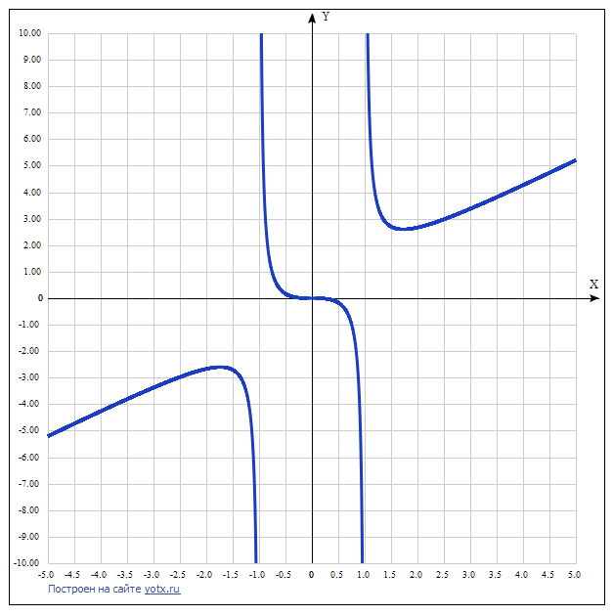

y(x)=x3/(x2−1) [Таблица точек](javascript:void(0);)

|  |  |
| --- | --- |
| **x** | **y** |
| -5.0 | -5.208 |
| -4.5 | -4.734 |
| -4.0 | -4.267 |
| -3.5 | -3.811 |
| -3.0 | -3.375 |
| -2.5 | -2.976 |
| -2.0 | -2.667 |
| -1.5 | -2.7 |
| -1.0 | - |
| -0.5 | 0.167 |
| 0 | 0 |
| 0.5 | -0.167 |
| 1.0 | - |
| 1.5 | 2.7 |
| 2.0 | 2.667 |
| 2.5 | 2.976 |
| 3.0 | 3.375 |
| 3.5 | 3.811 |
| 4.0 | 4.267 |
| 4.5 | 4.734 |
| 5.0 | 5.208 |

