My hobby is modeling. I collect different models of tanks from the company ZVEZDA. I like this company. I paint them in different camouflage, I make dioramas. I also collect cars of the Second World War, such as GAZ AA. I have four tanks and one truck in my collection. I started collecting models in 2019. But the first model was assembled in August 2018. It was a T-72B tank on a scale of 1.35. My favorite tank is PZ.4.H. I want to collect the tank T 34/85 and SU 100.I hope that my dreams will come tru 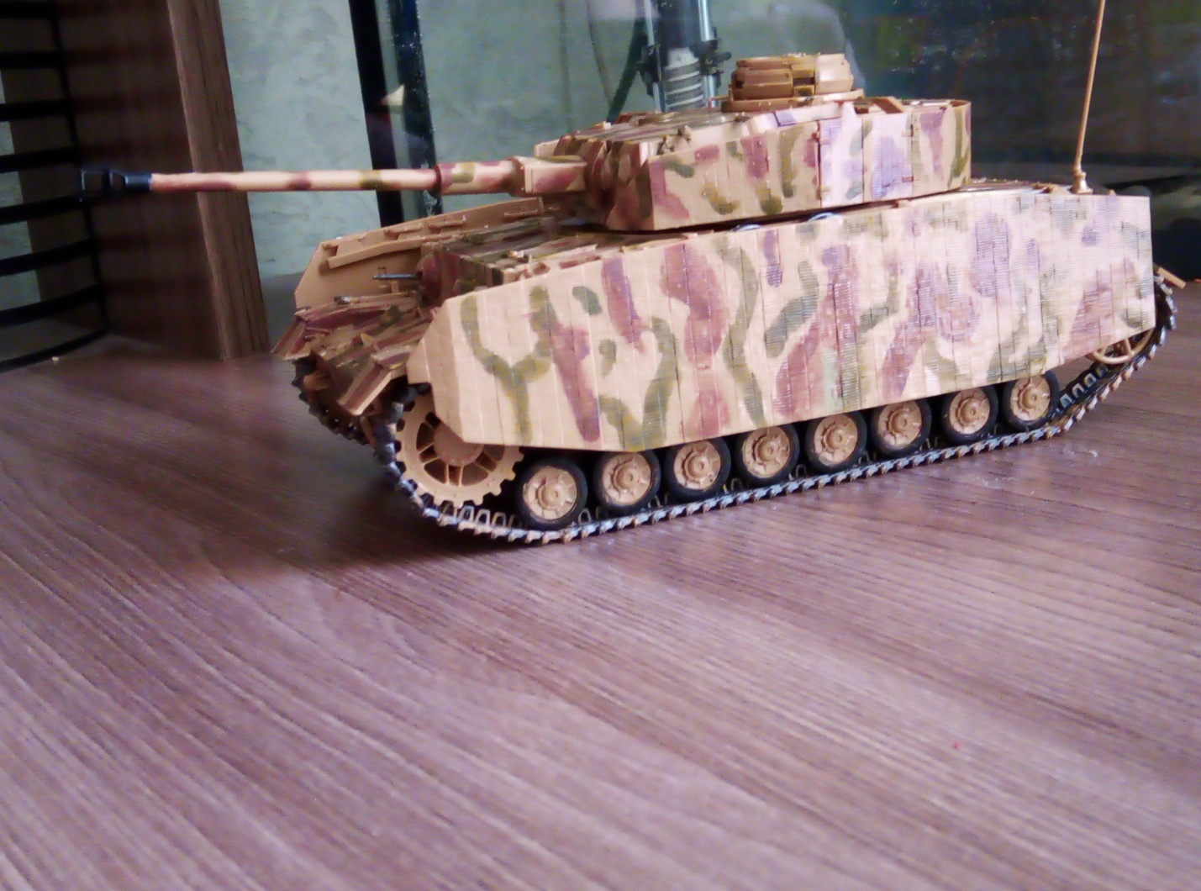

my favorite tank

Т 72В

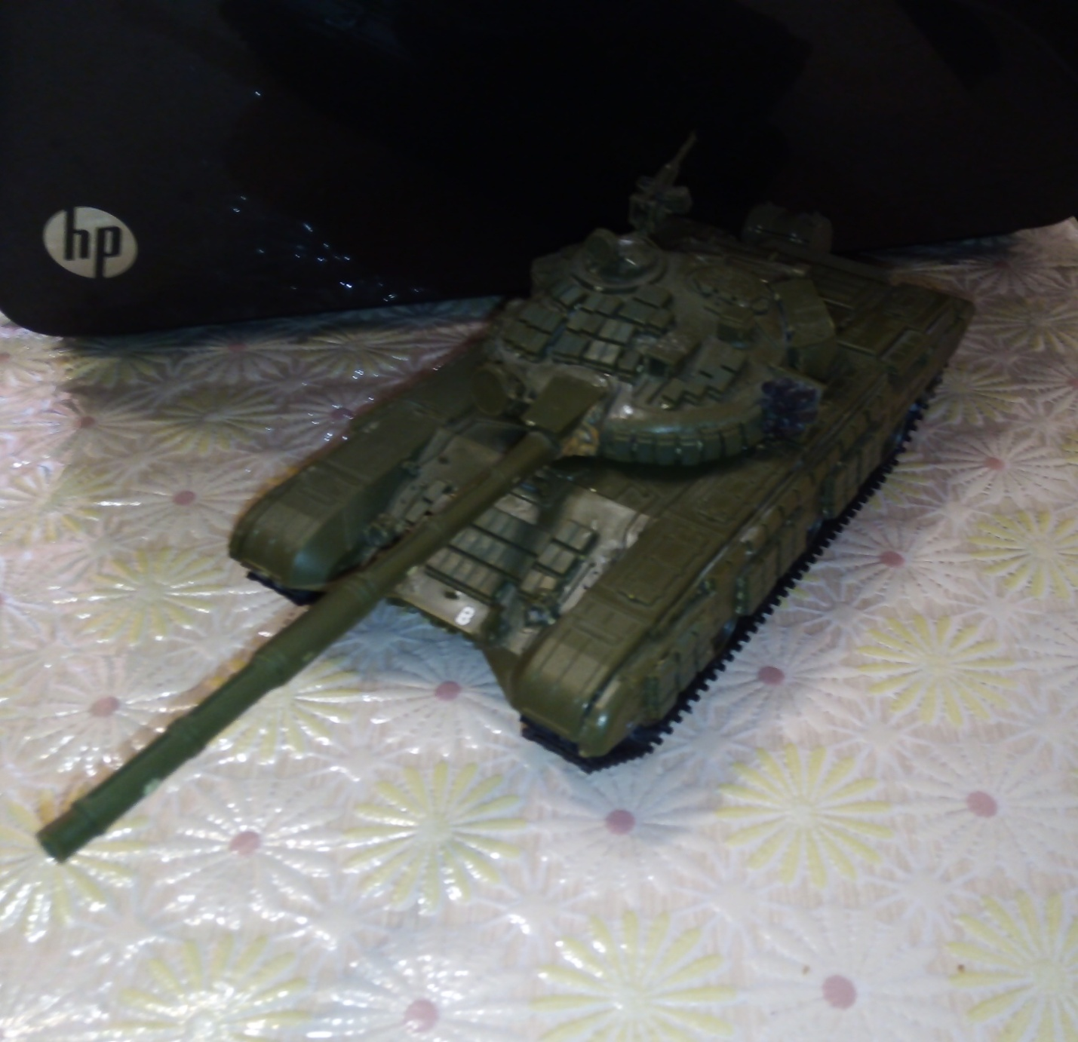

GAZ AA

