https://znanija.com/task/23964376
$$y=x^{3}-3x^{2}+4$$
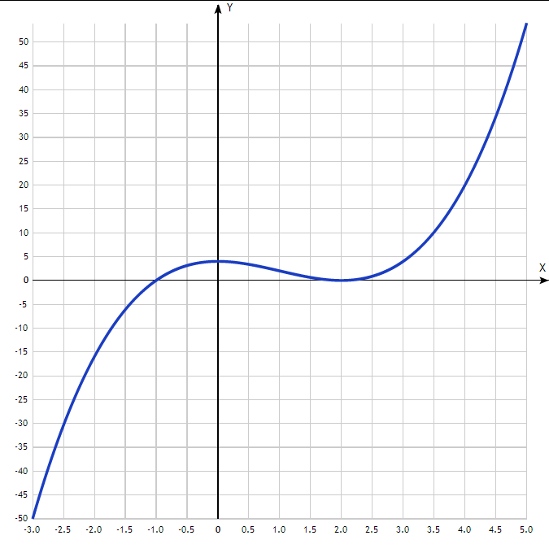

x | y
-3.0 | -50
-2.5 | -30.4
-2.0 | -16
-1.5 | -6.1
-1.0 | 0
-0.5 | 3.1
0 | 4
0.5 | 3.4
1.0 | 2
1.5 | 0.6
2.0 | 0
2.5 | 0.9
3.0 | 4
3.5 | 10.1
4.0 | 20
4.5 | 34.4
5.0 | 54

