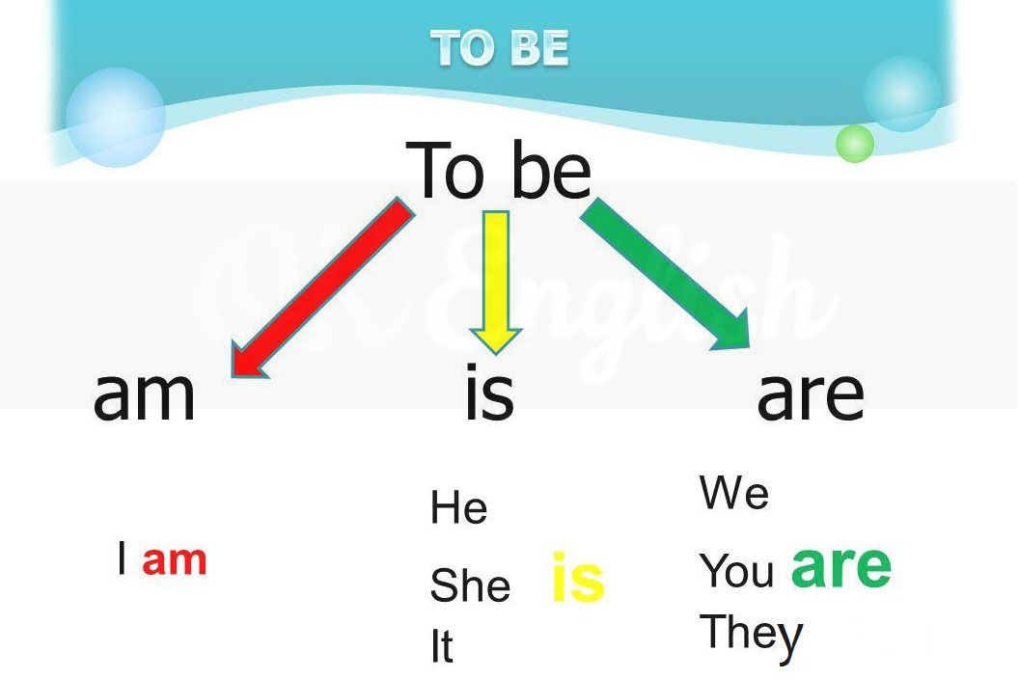
Вставьте глагол to be (am, is, are).
- You … brothers.
- I … a worker.
- My teacher … a tall.
- He … a driver.
- Her father … a doctor.
- You … a teacher.
- We … sisters.
- They … children.
- Their friends … pupils.
- My brother … a farmer.
- Her cat … grey.
- His brothers … students.
- She … an engineer.
- Tim and Don…pilots.
- My friends and I … pupils.

