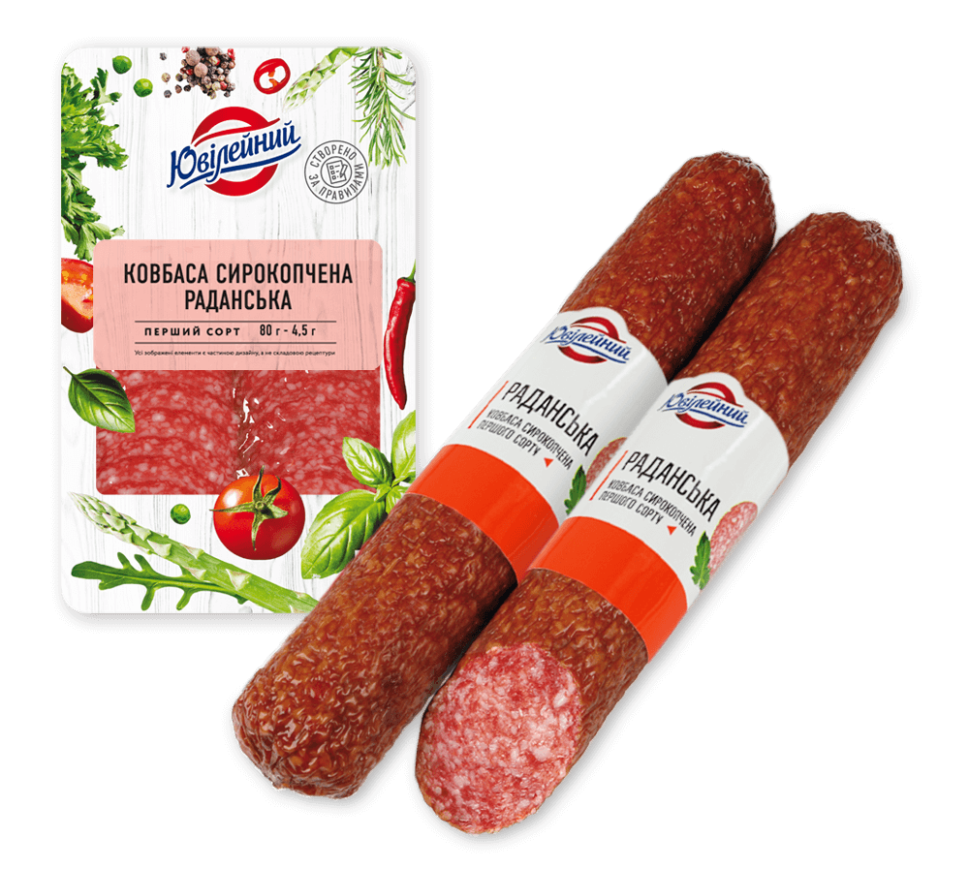
Olivier
Ingradients
1) potatoes - 4-5 pieces

2) carrots - 2 large or 3 medium

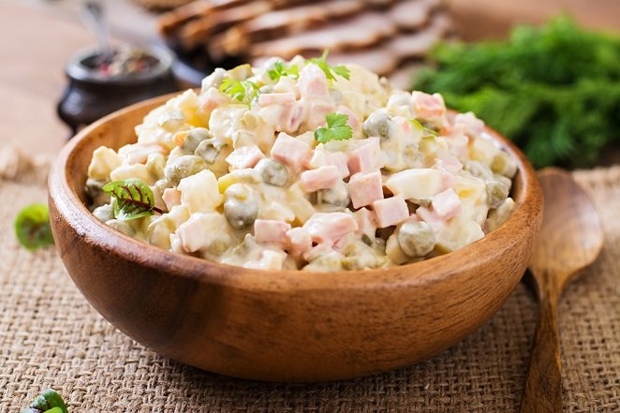
3) canned peas - 1 jar

4) sausage "Doctor's" - 300-400 g

5) salted or pickled cucumbers - 4-5 pieces

6) eggs - 6 pieces

7) onions - 1 piece


8) greens
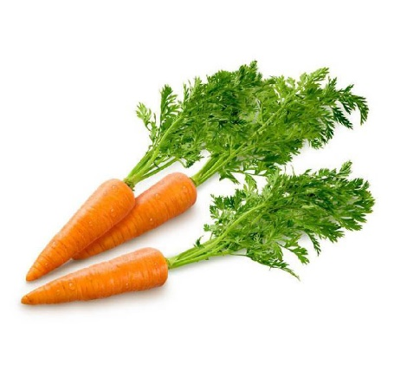
9) mayonnaise
Recipe
1. Boil potatoes and carrots "in uniforms". Boil the eggs.

2. Meanwhile, cut the sausage and cucumbers into small cubes.

3. Peel the prepared vegetables and eggs and also cut them into cubes.

4. Finely chop the onion.
5. Mix all ingredients, add peas and season with mayonnaise.

