Tasks for the Summative Assessment for the term 3
Name: __________________________________________________
Duration: 35 minutes
Use of English
Task 1 Complete the table.
Present | Past
finish
eat
play
give
have

[5]
Task 2. Complete the sentences.
- Nurlybek ________(have) a great birthday last August.
- _______________ (he/watch TV) last night?
- Bella ______________ (not/swim) last summer.
- We all _____________(dance) at Dana’s party.
- I__________ (do) my homework yesterday. [5]
Reading
Task 3. Read and write.
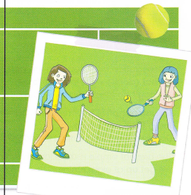
Anna and Helen are friends.
Yesterday they ______ (have) a nice time.
They__________ (finish) school at three.
Then they ______ (visit) a park after school.
They _______(play) tennis and _______ (eat) ice cream.
It was great!

[5]
[15]

