y(x)=cos(x)/x
Таблица точек
x | y
-3.0π | 0.11
-2.5π | 0
-2.0π | -0.16
-1.5π | 0
-1.0π | 0.32
-0.5π | 0
0 | -
0.5π | 0
1.0π | -0.32
1.5π | 0
2.0π | 0.16
2.5π | 0
3.0π | -0.11
y(x)=2(sin(x/2))²−2(cos(x/2))²
Показать таблицу точек
x | y
-4.0 | 1.31
-3.5 | 1.87
-3.0 | 1.98
-2.5 | 1.6
-2.0 | 0.83
-1.5 | -0.14
-1.0 | -1.08
-0.5 | -1.76
0 | -2
0.5 | -1.76
1.0 | -1.08
1.5 | -0.14
2.0 | 0.83
2.5 | 1.6
3.0 | 1.98
3.5 | 1.87
4.0 | 1.31

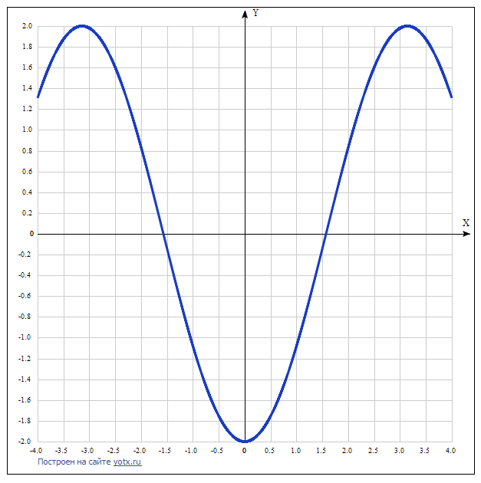

y(x)=abs(cos(2x))−1
Показать таблицу точек
x | y
-4.0 | -0.854
-3.5 | -0.246
-3.0 | -0.04
-2.5 | -0.716
-2.0 | -0.346
-1.5 | -0.01
-1.0 | -0.584
-0.5 | -0.46
0 | 0
0.5 | -0.46
1.0 | -0.584
1.5 | -0.01
2.0 | -0.346
2.5 | -0.716
3.0 | -0.04
3.5 | -0.246
4.0 | -0.854

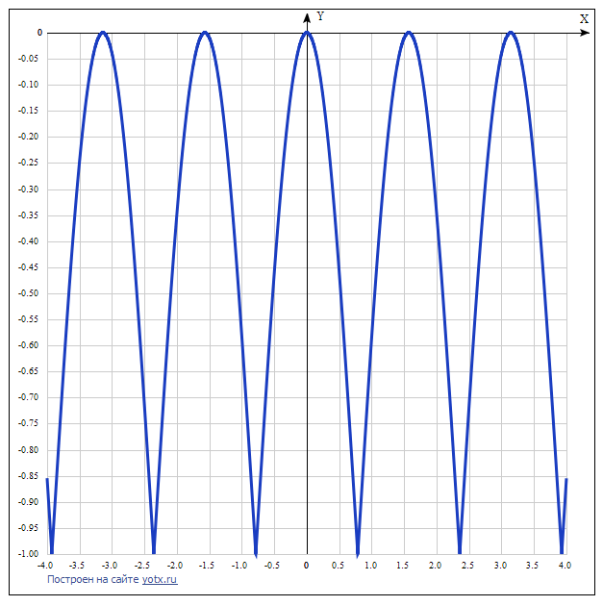

y(x)=2sin(x)+1
Показать таблицу точек
x | y
-4.0 | 2.51
-3.5 | 1.7
-3.0 | 0.72
-2.5 | -0.2
-2.0 | -0.82
-1.5 | -0.99
-1.0 | -0.68
-0.5 | 0.04
0 | 1
0.5 | 1.96
1.0 | 2.68
1.5 | 2.99
2.0 | 2.82
2.5 | 2.2
3.0 | 1.28
3.5 | 0.3
4.0 | -0.51

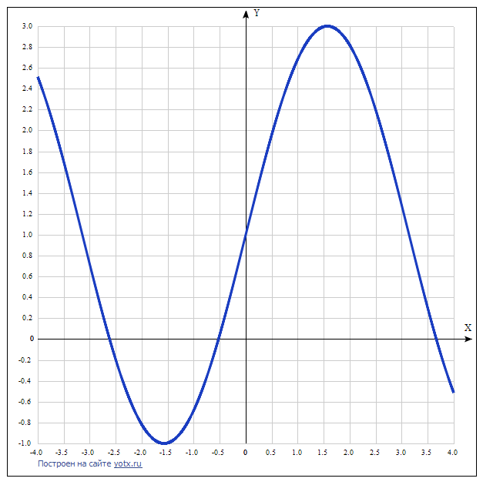

y(x)=sin(2x)/abs(cos(x))
Показать таблицу точек
x | y
-4.0 | -1.51
-3.5 | -0.7
-3.0 | 0.28
-2.5 | 1.2
-2.0 | 1.82
-1.5 | -1.99
-1.0 | -1.68
-0.5 | -0.96
0 | 0
0.5 | 0.96
1.0 | 1.68
1.5 | 1.99
2.0 | -1.82
2.5 | -1.2
3.0 | -0.28
3.5 | 0.7
4.0 | 1.51

