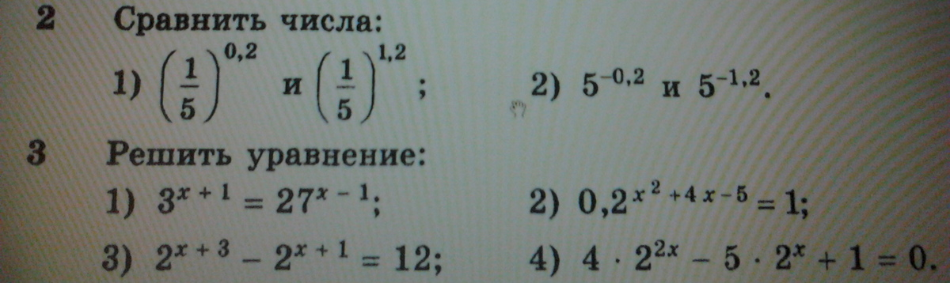
2-1)
${\left(\frac{1}{5}\right)}^{0,2}>{\left(\frac{1}{5}\right)}^{1,2}$так как $y(x)={\left(\frac{1}{5}\right)}^{x}$- убывающая функция и т.к. 0,2<1,2

2-2)
$5^{−0,2}>5^{−1,2}$так как $y(x)=5^{x}$- возрастающая функция и т.к. -0,2>-1,2

3-1)
$$\begin{aligned}3^{x+1}={\text{27}}^{\text{x-1}}=3^{\text{3x-3}} \\ x+1=3x−3 \\ x=2\end{aligned}$$

3-2)
$$\begin{aligned}{0,2}^{x^{2}+4х−5}=1={0,2}^{0} \\ x^{2}+4х−5=0 \\ x_{1}=−5; x_{2}=1\end{aligned}$$

3-3)
$$\begin{aligned}2^{x+3}−2^{x+1}=12 \\ 2^{x+1}=t>0 \\ \text{4t}−t=\text{12} \\ t=4=2^{x+1}=2^{2} \\ x+1=2 \\ x=1\end{aligned}$$

3-4)
$$\begin{aligned}4∗2^{\text{2x}}−5∗2^{x}+1=0 \\ 2^{x}=t>0 \\ 4t^{2}−5t+1=0 \\ d=\text{25}−\text{16}=9 \\ t_{1}=\frac{5−3}{8}=\frac{1}{4}=2^{x}=2^{\text{-2}} \\ x_{1}=−2 \\ t_{2}=\frac{5+3}{8}=1=2^{x}=2^{0} \\ x_{2}=0\end{aligned}$$

