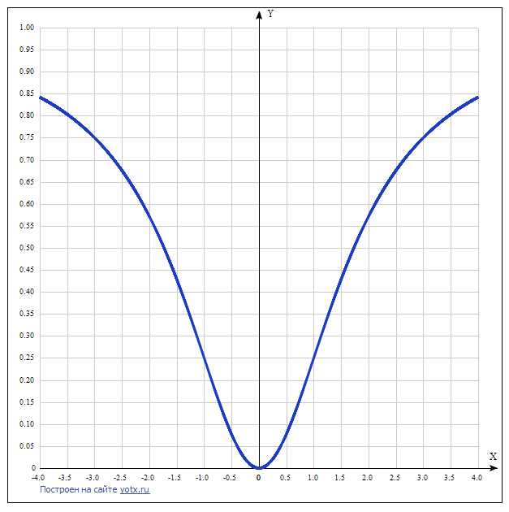
y(x)=x²/(x²+3) Таблица точек

x | y
-4.0 | 0.842
-3.5 | 0.803
-3.0 | 0.75
-2.5 | 0.676
-2.0 | 0.571
-1.5 | 0.429
-1.0 | 0.25
-0.5 | 0.077
0 | 0
0.5 | 0.077
1.0 | 0.25
1.5 | 0.429
2.0 | 0.571
2.5 | 0.676
3.0 | 0.75
3.5 | 0.803
4.0 | 0.842

