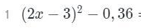$={\left(2x-3\right)}^{2}-{0,6}^{2}=\left(2x-3-0.6\right)(2x-3+0.6)$ =
=(2x-3.6)(2x-2,4)

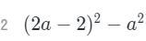$=\left(2a-2-a\right)\left(2a-2+a\right)=\left(a-2\right)\left(3a-2\right)$

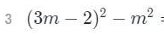$=\left(3m-2-m\right)\left(3m-2+m\right)=\left(2m-2\right)\left(4m-2\right)$

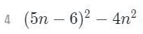$=\left(5n-6-2n\right)\left(5n-6+2n\right)=\left(3n-6\right)(7n-6)$

$\frac{sin216}{sin72}-\frac{cos216}{cos72}=$ 2

Используем формулы
$\sin{3α} = 3\sin{α}–4\sin^{3}{α }$
$cos 3α = 4\cos^{3} α –3cos α$

$\frac{sin3*72}{sin72}=\frac{3sin72-4\sin^{3}{72}}{sin72}=3-4\sin^{2}{72}$

$\frac{cos⁡(3*72)}{cos72}=\frac{4cos^{3}72-3cos72}{cos72}=4\cos^{2}72-3$

$3-4\sin^{2}{72}-\left(4\cos^{2}72-3\right)=3-4\sin^{2}{72-4\cos^{2}{72+3=6-4(\sin^{2}{72+\cos^{2}{72)=}} }}$

= 6 – 4 = 2
Тема: Похідна
Знайти похідну:
- у=2х
- у=12х
- у=45х
- у=-7х
- у=-34х
- у=-123х
- у=56х+6
- у=78-1,3х
- у=х²
- у=х³
- у=х²⁵
- у=х¹⁴⁶
- у=х⁻⁶
- у=х⁻¹¹
- у=х⁻⁸⁹
- 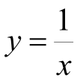
- 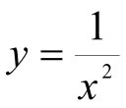
- 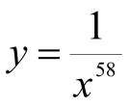
- 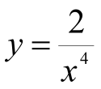
- 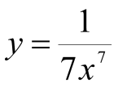
- 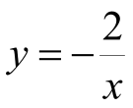
- 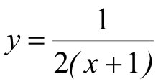
- 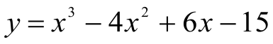
- 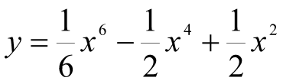
- 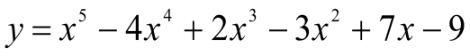
- 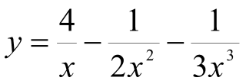
- 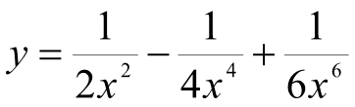
- 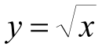
- 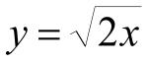
- 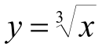
- 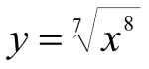
- 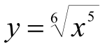
- 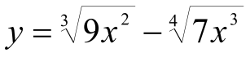
- 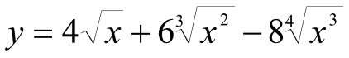
- 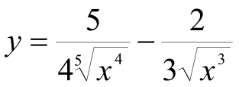
- 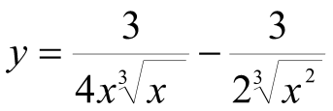
- у=е^{2х}
- у=е^{6х-2}
- у=cos2x
- y=sin(x+1)
- y=tg(x-4)
- y=ctg(x²)
- y=cos(x²-3x+7)
- y=sin(5x+x⁵-8)
- y=e^{x}lnx
- y=xlog₂(x+1)
- 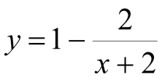
- 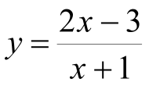
- 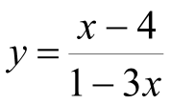
- 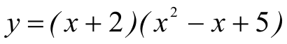
- 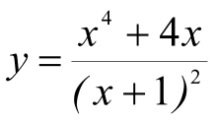
- 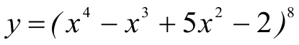
- 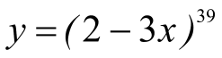
- 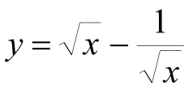
- 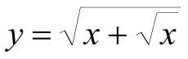
- 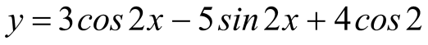
- 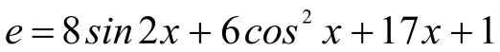
- 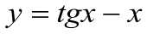
59.