Grammar
1. Choose the correct answers.
1 The telephone rang while I a shower.
a had b was having c were having
2 When you last night, I was reading a book.
a phoned b was phoning c were phoning
3 We saw Henry while we for the bus.
a waited b was waiting c were waiting
4 We were having dinner when Helen .
a came b was coming c were coming
5 While Bill and Kate their homework, their mother called them.
a did b was doing c were doing

2. Complete the sentences with the correct form of going to and the verbs in the box.
buy call not / cook not / walk take visit
1. I’m going to take some photos tomorrow. 2 Maria is going to visit her grandparents next week.
3. Tim isn’t going to cook dinner tonight. 4. Tom and Jim aren’t going to walk to school tomorrow.
5. We are going to buy a new computer. 6.They are going to call me tonight.

___/6 marks
3 Complete the questions and answers with going to and the verbs in the box.
buy do go have invite (x2) watch
1 A What are you going to do tomorrow?
B I’ m going to go shopping.
2 A Are we going to watch the DVD tonight?
B Yes, we are.
3 A Who is she going to invite to the party?
B She is going to invite David.
4 A Is he going to buy a new sports car?
B No, he isn’t.
5 A Are they going to have a baby?
B No, they aren’t.

___/10 marks

4. Complete the sentences with should or shouldn’t.
1 It’s hot. They should open the window.
2 You shouldn’t watch TV all night.
3 He should brush his teeth twice a day.
4 You should call your parents. They’re worried.
5 We shouldn’t be late for school.

___/5 marks

5. Complete the sentences with must or mustn’t.
1 You mustn’t use your mobile phone in the classroom.
2 I must give the dog some water. He’s thirsty.
3 Stop it! You mustn’t be rude to people.
4 I must go home now. It’s late.
5 They mustn’t drop litter.

___/5 marks
Vocabulary
1 Look at the pictures and complete the sentences with the words in the box.
clean cut damage plant pollute protect recycle reuse save throw turn waste

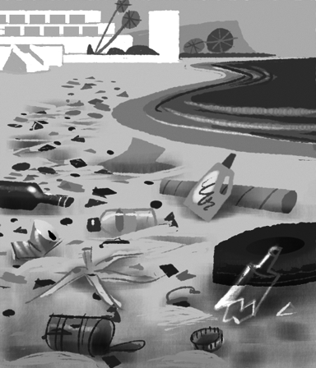  1 Let’s clean the beach up.  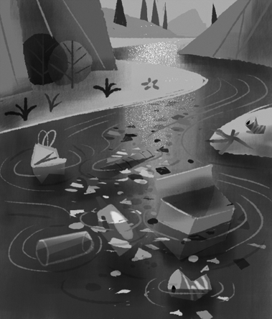  3 Don’t pollute the rivers!  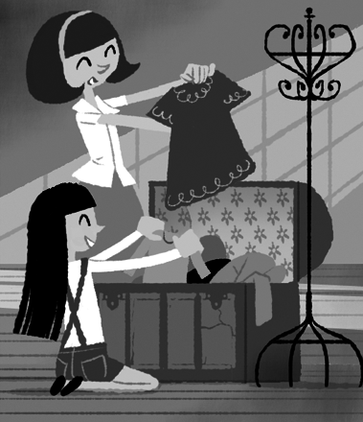  5 We should recycle clothes  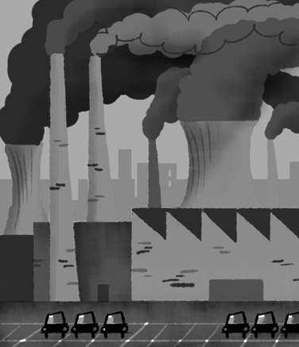  7 Don’t damage the environment.  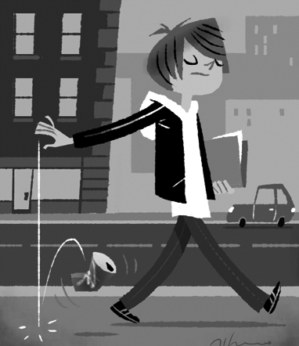  9 Don’t throw the can away! | 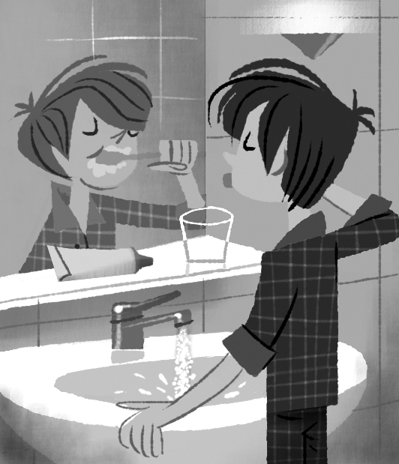  2 Don’t waste all that water!  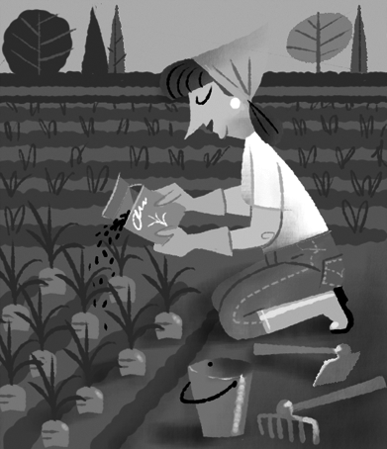  4 Let’s plant some vegetables.  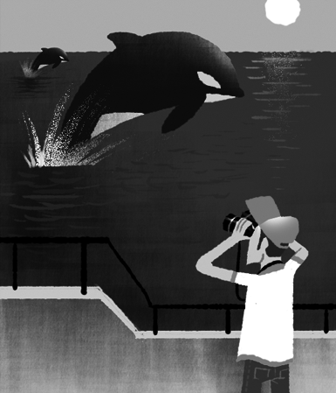  6 protect the whale!  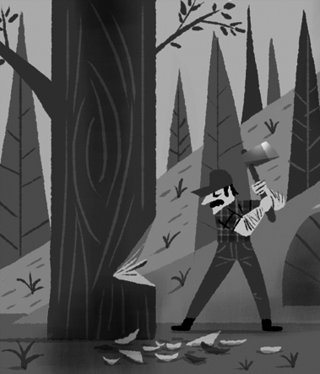  8 Don’t cut those trees down!  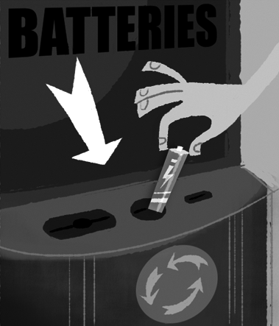  10 reuse those things.

2 Complete the sentences with the words in the box.
away down off plant save up
1 Please help me clean the kitchen up before Mum comes home.
2 We must save these beautiful animals. They are in danger.
3 Why did they cut all the trees down?
4 I must plant some flowers in the garden this spring.
5 Please turn the TV off when you leave the room.
6 Please don’t throw those books away. Give them to your school library.
___/6 marks

3 Complete the sentences with words for materials or containers.
1 Don’t throw the paper bags in the bin.
2 The fruit is on the wooden table.
3 There is a bottle of water over there.
4 Is there honey in the glass jar?
5 I want a carton of milk from the supermarket.
6 The sugar is in a metal can.

___/6 marks

Speaking
1 Complete the dialogue with the words in the box.
any awesome cheap expensive help how much it’s sure take thanks
Shop assistant Good morning. Can I ¹ help you?
Claire Yes, please. Have you got ²any nice
T-shirts?
Shop assistant ³Sure . We’ve got lots. These are from India.
Claire ⁴Awesome! I like them all!
⁵haw much is this blue
T-shirt?
Shop assistant ⁶it’s 25€.
Claire That’s expensive. I don’t want it, thanks ⁸.
Shop assistant Those T-shirts are cheaper. The white
T-shirt is 5€.
Claire That’s ⁹cheap. I’ll
¹⁰ take it.

___/10 marks

Total: ___/60 marks

