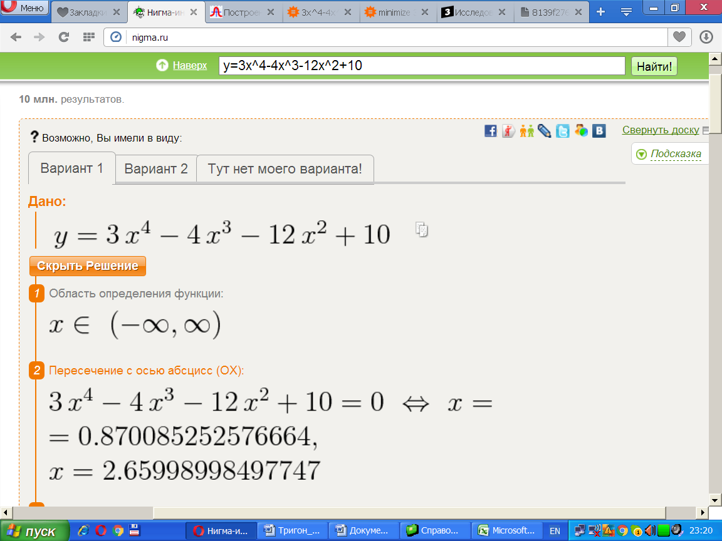
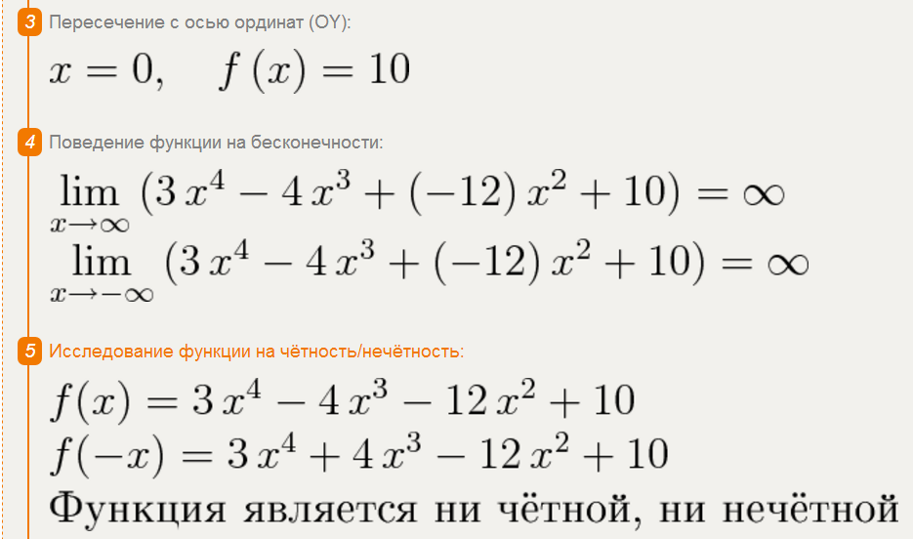
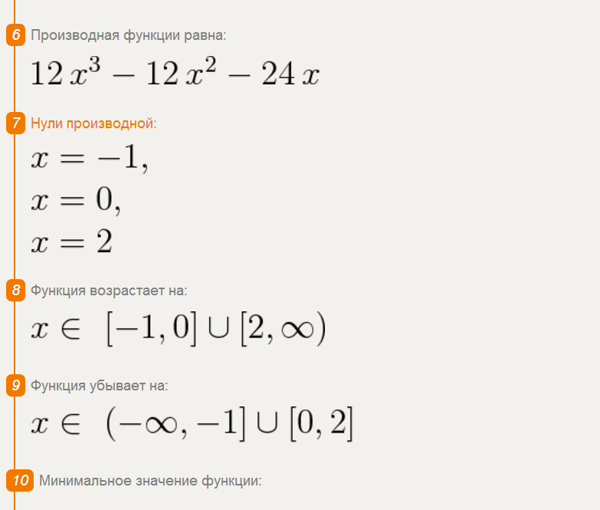
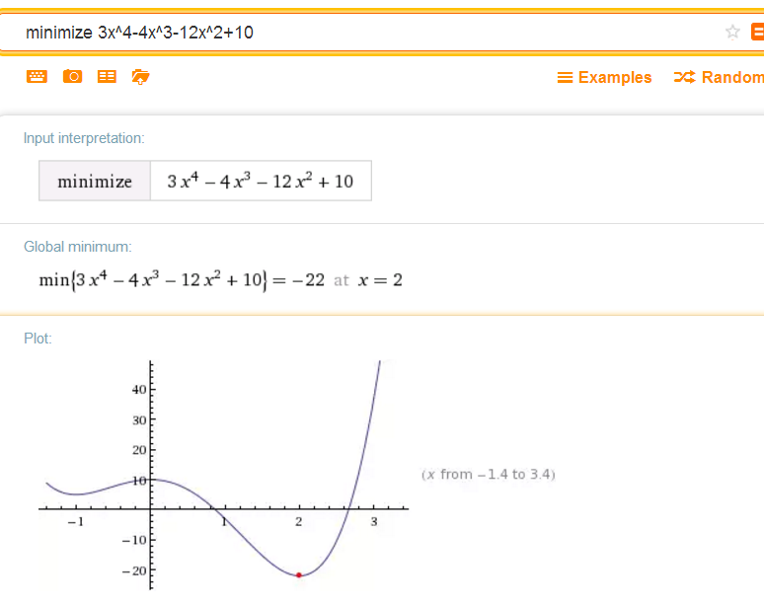
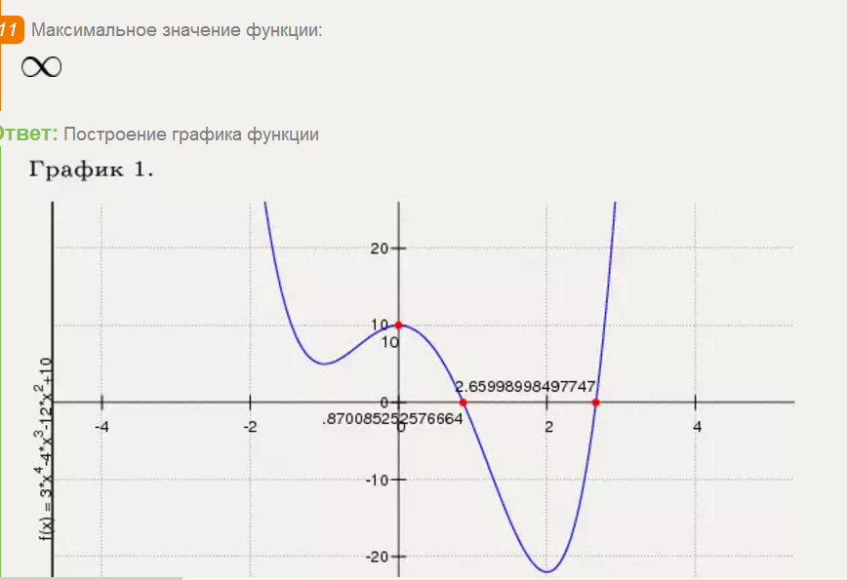
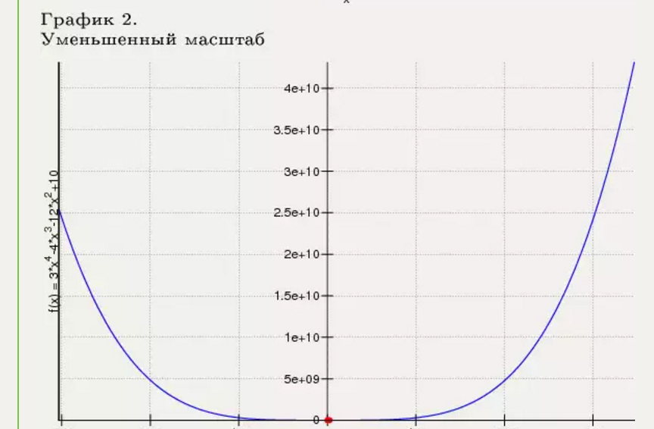

y(x)=3x⁴−4x³−12x²+10 Таблица точек

x | y
-3.0 | 253
-2.5 | 114.7
-2.0 | 42
-1.5 | 11.7
-1.0 | 5
-0.5 | 7.7
0 | 10
0.5 | 6.7
1.0 | -3
1.5 | -15.3
2.0 | -22
2.5 | -10.3
3.0 | 37
3.5 | 141.7
4.0 | 330

