Дано:

[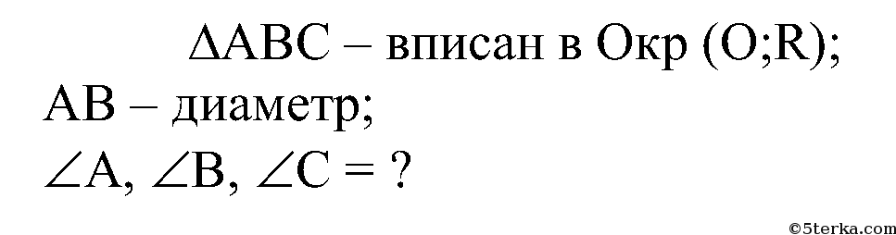](http://5terka.com/images/geom79atanasyan/geom8atan-1157.png)[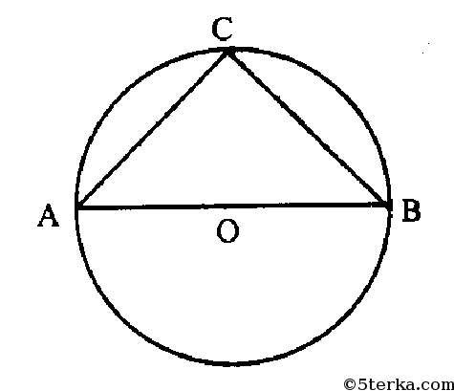](http://5terka.com/images/geom79atanasyan/geom8atan-1158.png)

Решение:

[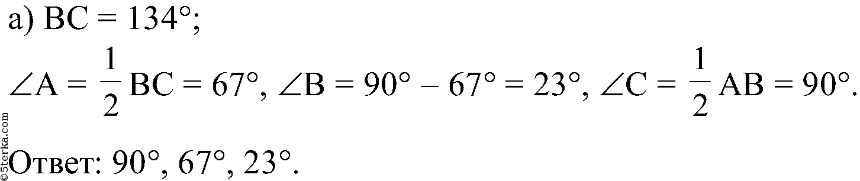](http://5terka.com/images/geom79atanasyan/geom8atan-1159.png)[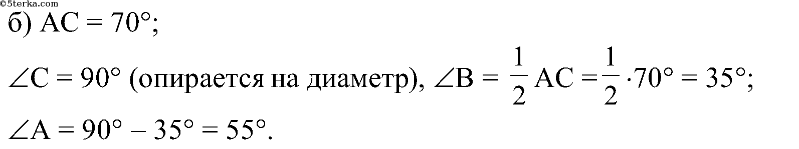](http://5terka.com/images/geom79atanasyan/geom8atan-1160.png)

Ответ:

[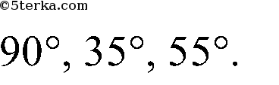](http://5terka.com/images/geom79atanasyan/geom8atan-1161.png)