https://znanija.com/task/24122174

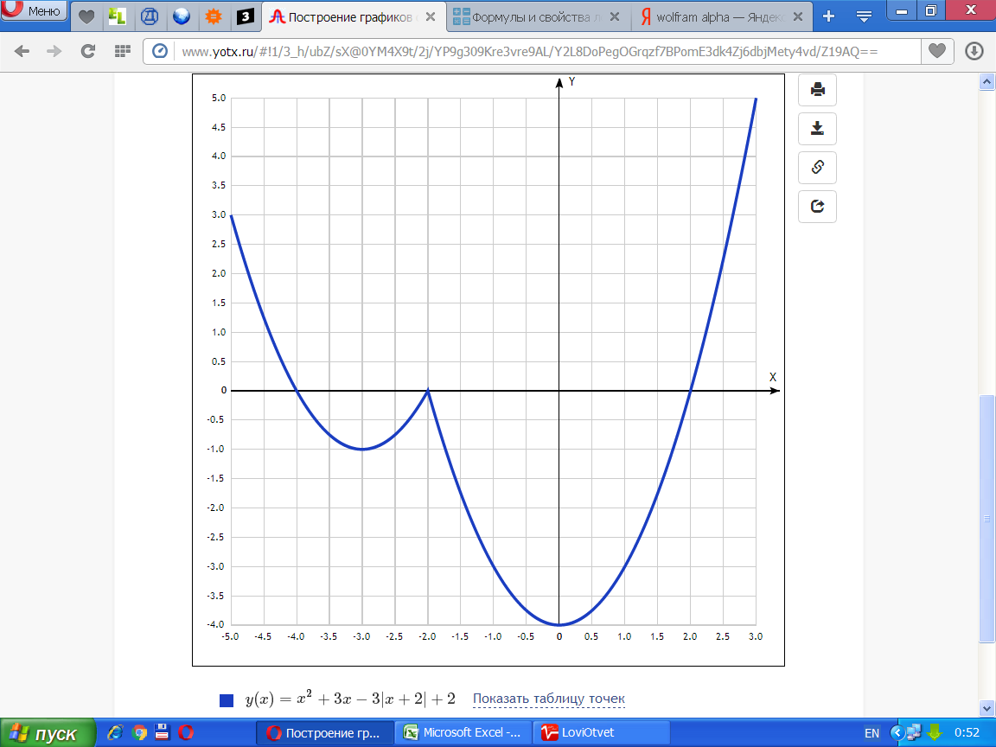

[Таблица точек](javascript:void(0);)

|  |  |
| --- | --- |
| **x** | **y** |
| -5.0 | 3 |
| -4.5 | 1.25 |
| -4.0 | 0 |
| -3.5 | -0.75 |
| -3.0 | -1 |
| -2.5 | -0.75 |
| -2.0 | 0 |
| -1.5 | -1.75 |
| -1.0 | -3 |
| -0.5 | -3.75 |
| 0 | -4 |
| 0.5 | -3.75 |
| 1.0 | -3 |
| 1.5 | -1.75 |
| 2.0 | 0 |
| 2.5 | 2.25 |
| 3.0 | 5 |

$$y=\left|x\right|\left(x-1\right)-5x$$

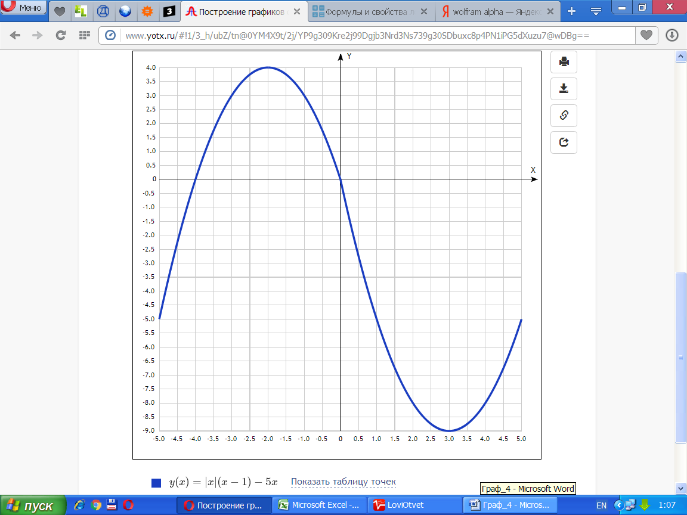

|  |  |
| --- | --- |
| **x** | **y** |
| -5.0 | -5 |
| -4.5 | -2.25 |
| -4.0 | 0 |
| -3.5 | 1.75 |
| -3.0 | 3 |
| -2.5 | 3.75 |
| -2.0 | 4 |
| -1.5 | 3.75 |
| -1.0 | 3 |
| -0.5 | 1.75 |
| 0 | 0 |
| 0.5 | -2.75 |
| 1.0 | -5 |
| 1.5 | -6.75 |
| 2.0 | -8 |
| 2.5 | -8.75 |
| 3.0 | -9 |
| 3.5 | -8.75 |
| 4.0 | -8 |
| 4.5 | -6.75 |
| 5.0 | -5 |

$$y=\frac{4x-5}{4x^{2}-5x}$$

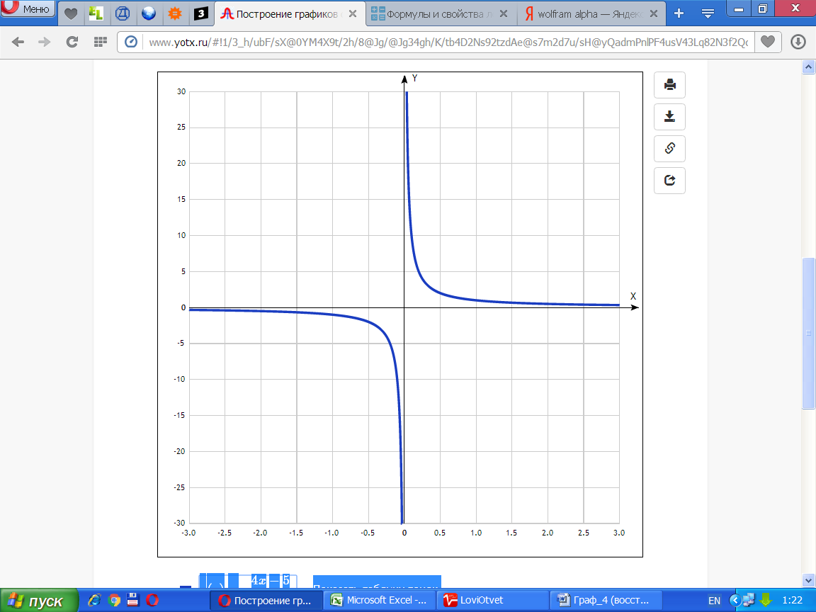

|  |  |
| --- | --- |
| **x** | **y** |
| -3.0 | -0.3 |
| -2.5 | -0.4 |
| -2.0 | -0.5 |
| -1.5 | -0.7 |
| -1.0 | -1 |
| -0.5 | -2 |
| 0 | - |
| 0.5 | 2 |
| 1.0 | 1 |
| 1.5 | 0.7 |
| 2.0 | 0.5 |
| 2.5 | 0.4 |
| 3.0 | 0.3 |