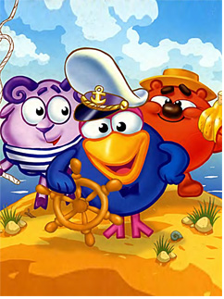
Аt a break

crossword, stories,
a horoscope, some jokes

crossword
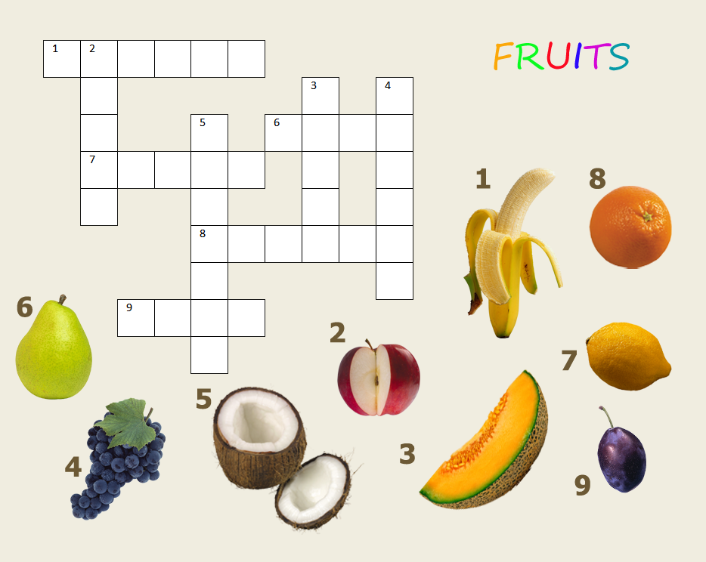
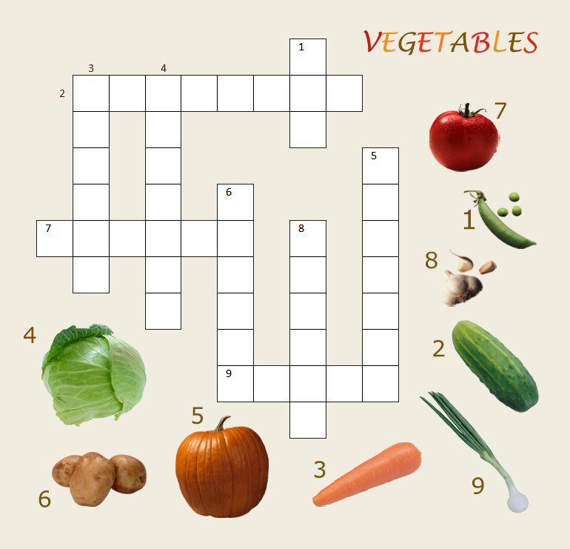

The Tortoise and the Hare

The hare was once boasting of his speed before the other animals. "I have never yet been beaten," said he, "when I put forth my full speed. I challenge anyone here to race with me."
The tortoise said quietly, "I accept your challenge."
"That is a good joke," said the hare. "I could dance around you all the way."
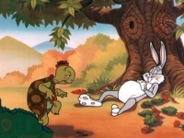
"Keep your boasting until you've beaten," answered the tortoise. "Shall we race?"
So a course was fixed and a start was made. The hare darted almost out of sight at once, but soon stopped and, to show his contempt for the tortoise, lay down to have a nap. The tortoise plodded on and plodded on, and when the hare awoke from his nap, he saw the tortoise nearing the finish line, and he could not catch up in time to save the race.
Plodding wins the race.

Тhe Purse of Gold


A beggar found a leather purse that someone had dropped in the marketplace. Opening it, he discovered that it contained 100 pieces of gold. Then he heard a merchant shout, "A reward! A reward to the one who finds my leather purse!"
Being an honest man, the beggar came forward and handed the purse to the merchant saying, "Here is your purse. May I have the reward now?"

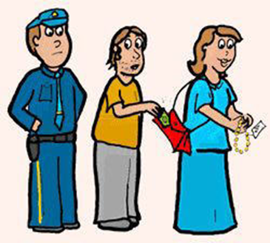
"Reward?" scoffed the merchant, greedily counting his gold. "Why the purse I dropped had 200 pieces of gold in it. You've already stolen more than the reward! Go away or I'll tell the police."
"I'm an honest man," said the beggar defiantly. "Let us take this matter to the court."
In court the judge patiently listened to both sides of the story and said, "I believe you both. Justice is possible! Merchant, you stated that the purse you lost contained 200 pieces of gold. Well, that's a considerable cost. But, the purse this beggar found had only 100 pieces of gold. Therefore, it couldn't be the one you lost."

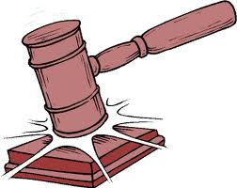
And, with that, the judge gave the purse and all the gold to the beggar.

А horoscope
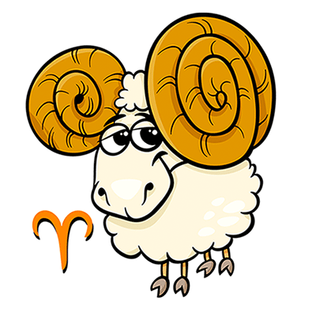
Aries-
Feel like you're tripping over your own tongue? That's not surprising, considering the constant flow of verbosity that's spilling forth from you right now. Go ahead and enjoy your extreme eloquence -- everyone else is.

Leo
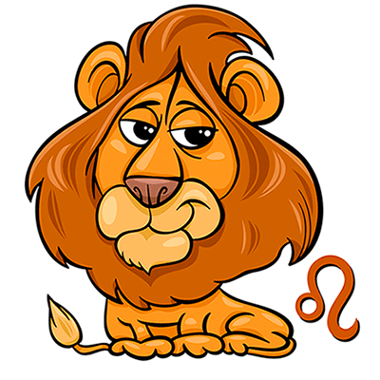
You may feel ready to move into a decisive new leadership role, but the stars say to let things gestate for a little while longer before you make your big move. Try talking things over with your boon companions and hear what they have to say.

Sagittarius
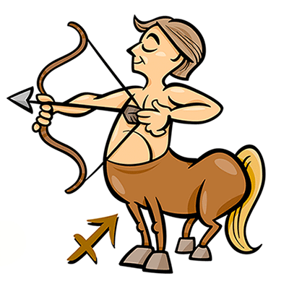
Having this much activity going on around you can be somewhat unsettling, but don't sulk. Just because something seems out of sync doesn't mean it'll be that way permanently. Wait it out and you'll feel things start to jell.

Taurus

Stay in the now rather than trying to jump forward into the future. You'll do best when you focus your attention on all the immediate details that require your assistance. Remember that, no matter how tempting it is to start booking yourself weeks in advance.

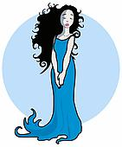
Virgo

Don't try to do more than you can comfortably handle -- and make sure you're very clear about your limits if others try to ask you to take more on. When possible, lighten your load rather than add more to it.

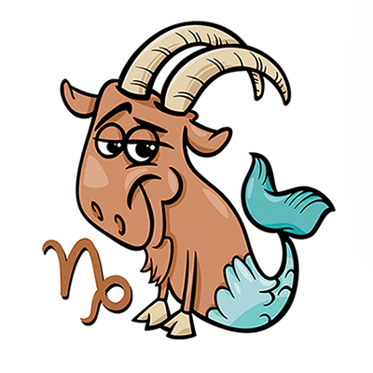
Capricorn

Put the kibosh on anyone who's absolutely determined to make sure even the smallest things go haywire. With a little extra care, you can defuse this live wire before they make life any more difficult than it is.

Gemini
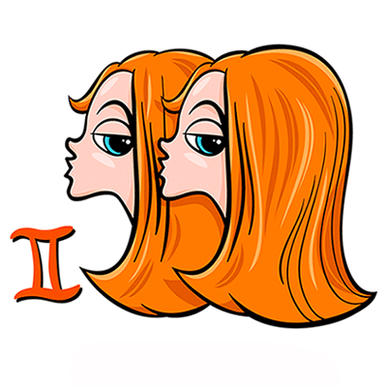
From you, a wink and a smile go beyond a thousand words -- they're practically an entire romantic saga. Your flirty energy livens things up wherever you go right now, so make sure that as many people as possible can appreciate your fabulous self.

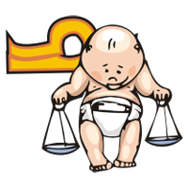
Libra

You love watching this new scenario unfold in your life, but suddenly watching it isn't enough. You want -- no, you need -- to take action, but you're not sure which way to turn. Take a moment and look before you leap.

Aquarius
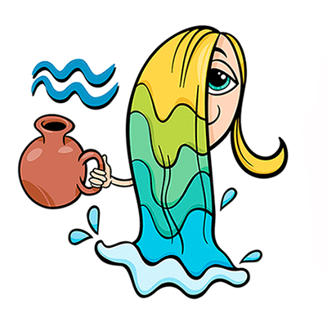
Taking other people's opinions into consideration is usually the last item on your list of priorities, and that goes double when it comes to a very new and very exciting person in your life.

Cancer
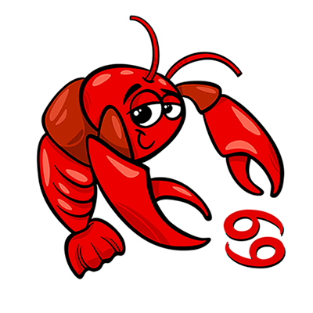
For the first time in a very long time, you're listening only to one authority -- yourself. This is especially true regarding a social matter. You've been worried far too long about doing the right thing. Now it's time to do right by you.

Scorpio
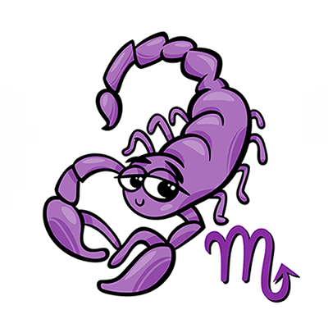
Minor details could become major mistakes if they're left unchecked, but fortunately, there's plenty of time to check everything. Not only will this ensure your enterprise will go swimmingly, but it'll give you some much-needed peace of mind.

Pisces
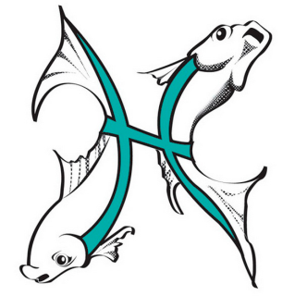
Learn to deal with ambiguity by letting it exist, rather than trying to make it go away. If you act too rapidly, you might just find that the solution becomes a much larger problem than the original situation.

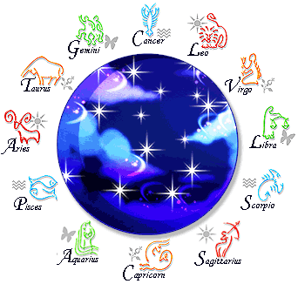

some jokes

- A teacher was asked to fill out a special questionnaire. One question said, "Give two reasons for entering the teaching profession." The teacher wrote: "July and August."
- Teacher: What is the purpose of having school?
Student: Without school there wouldn't be a reason for holidays and summer vacation.

- Physics Teacher: Isaac Newton was sitting under a tree when an apple fell on his head and he discovered gravity. Isn't that wonderful? Student: Yes sir, if he had been sitting in class looking at books like us, he wouldn't have discovered anything.
- Teacher: Class, we will have only half a day of school this morning.
Class: Hooray!

Teacher: We will have the other half this afternoon.
- Mom: What did you do at school today?
Tom: We did a guessing game.
Mom: But I thought you were having a math exam.
Tom: That’s right!
- Kate: Why was school easier for cave people?
Jim: Why?
Kate: Because there was no history to study!

- The human brain is special. It starts working as soon as you get up and it doesn't stop until you get to school.

