1

l

1 m
2
n
3
4 k
5

2
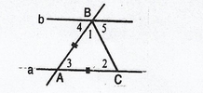
3

A M B

C N D

