Theme: Work and money
Read the text
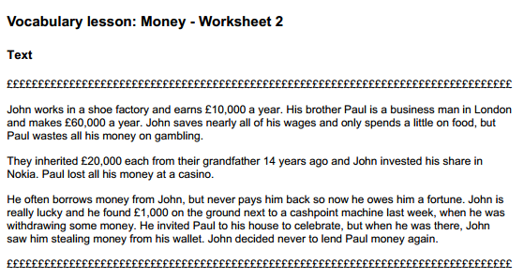

Answer the questions YES/NO
1.Are John and Paul brothers?
2.Does John work in a shop?
3.Did Paul waste all his money at a casino?
4. Did they inherit 10000 each from their grandfather?
5. Does Paul often borrow money from John?
6. Did Paul find money next to a cashpoint?
7. Did Paul steal money from John’s wallet?
