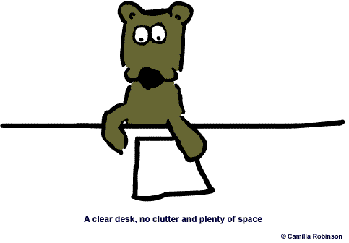

***Let’s revise Verb Tenses.***

**Fill in the following blanks using the correct forms of the verbs in brackets. Use simple present, present continuous, simple past, and going to.**

**Tip! Highlight time markers and read the whole sentence to get a clear idea of what it is about.**

1. Henry usually _______________ (wake) up at 8 o'clock.
2. My brother and my sister _______________ (have) breakfast at the moment.
3. Peter _______________ (buy) a new bicycle yesterday.
4. We _______________ (live) in Córdoba, Argentina.
5. I _______________ (do) my Maths homework tonight.
6. Be careful! Somebody_______________ (follow) us.
7. My father never _______________ (drink) Coke before he _______________ (go) to bed. He _______________(say) it _______________(keep) him awake.
8. Neil: Where ___________ you _______________ (go) last Sunday?

Laura: _______________ (go) to the cinema.

1. “Look, my sister is not at home right now, but don't worry. She will phone you as soon as she_______________ (come) back” .
2. I _______________ (not see) my friends last night at the party, I _____________ (feel) like a fish out of water.
3. My grandmother _______________ (go) to church every Sunday.
4. Please_______________ (call) me when the news_______________ (start) .
5. Peter: _________ Tom ________________(pack) his suitcases yesterday?

Sam: Yes, he did. You know how obsessed he is, he always __________________(want) to have everything perfectly organised.

1. ___________ Kevin always_________________ (start) work so late? If he ______________(continue) like this, he ___________________________(lose) his job.
2. I overslept!!! I ___________________(phone) to see if they __________ still_____________ (wait) for me.
3. Sue _______________ (sell) her car last Sunday. Now she ______________(have) the money to buy a new one.
4. My father _____________(leave) to work very early in the morning so, he never_____________ (have) breakfast at home. He usually _______________(have) a cup of coffee in his office.
5. I_____________________ (visit) my grandparents next week.